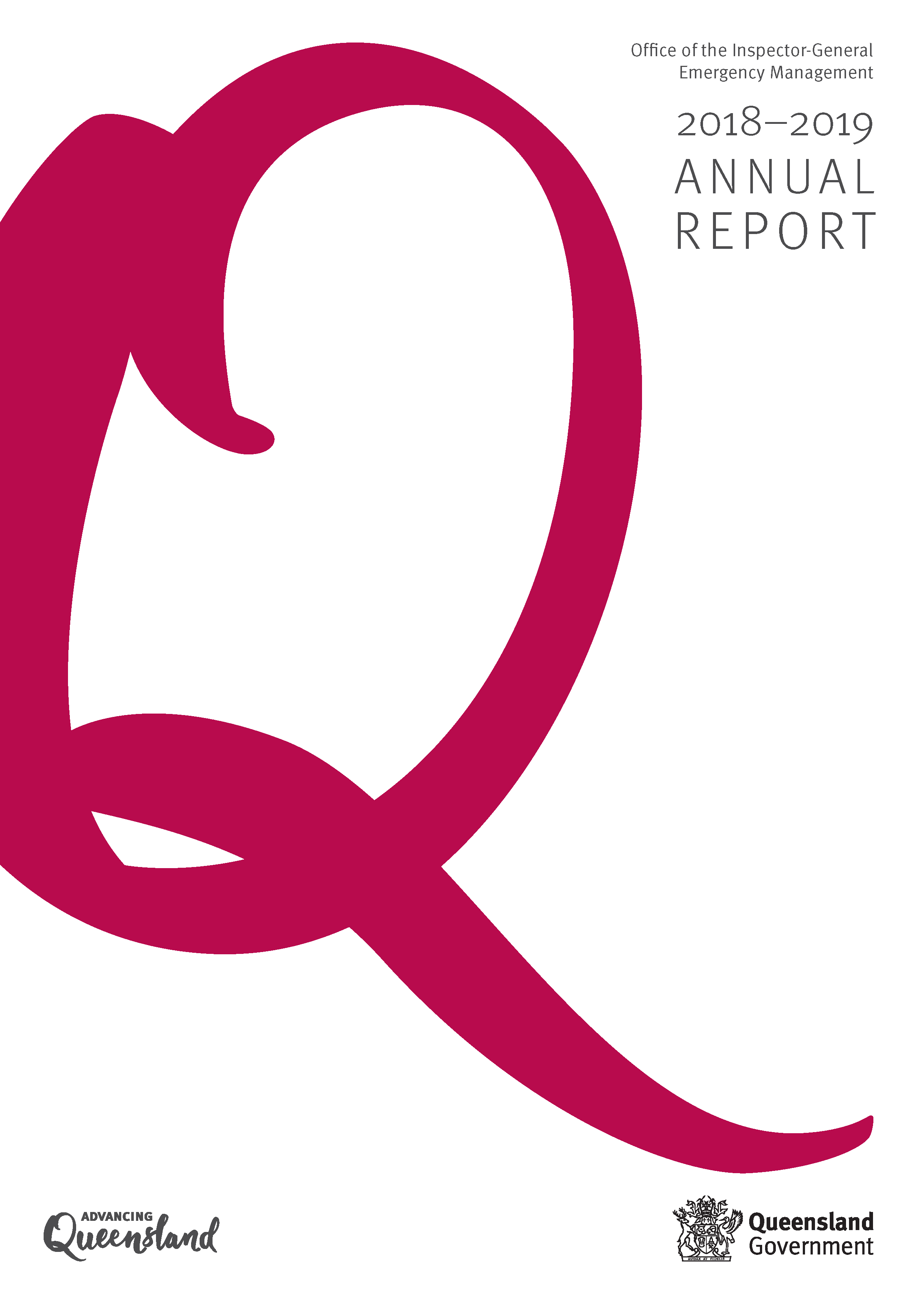

<Office of the Inspector-General Emergency Management>

<2018–19 Annual Report>

**Acknowledgement of Country**

The Office of the Inspector-General Emergency Management acknowledges the Aboriginal peoples and Torres Strait Islander peoples as the Traditional Owners and Custodians of this Country. We recognise and honour their ancient cultures, and their connection to land, sea and community. We pay our respect to them, their cultures, and to their Elders, past, present and emerging.

**Purpose**

This annual report provides information about the Office of the Inspector-General Emergency Management financial and non‑financial performance for2018–19. It has been prepared in accordance with the *Financial Accountability Act 2009*, the *Financial and Performance Management Standard 2019* and the *Annual report requirements for Queensland Government agencies*.

The annual report includes the significant achievements against the objectives and strategies detailed in the *Office of the Inspector-General Emergency Management Strategic Plan 2018–22* and the *Service Delivery Statement 2018–19*.

**Enquiries and further information**

Telephone: (07) 3029 8813

Visit: [www.igem.qld.gov.au](http://www.igem.qld.gov.au)

Email: [info@igem.qld.gov.au](mailto:info@igem.qld.gov.au)

[www.facebook.com/  
InspectorGeneralEmergencyManagement](http://www.facebook.com/InspectorGeneralEmergencyManagement)

This annual report is available on the Office of the Inspector-General Emergency Management website at [www.igem.qld.gov.au/reports-and-publications/annual-reports/Pages/default.aspx](http://www.igem.qld.gov.au/reports-and-publications/annual-reports/Pages/default.aspx) or a paper copy can be provided on request by telephoning (07) 3029 8813.

Information about consultancies, overseas travel and the *Queensland Language Services Policy* is available at the Queensland Government Open Data website [www.data.qld.gov.au](http://www.data.qld.gov.au)

**Other languages and formats**

The Queensland Government is committed to providing accessible services to Queenslanders from all culturally and linguistically diverse backgrounds. If you have difficulty in understanding the annual report, you can contact us on telephone (07) 3029 8813 and we will arrange an interpreter to effectively communicate the report to you.

**Feedback**

Feedback on the annual report can be provided through the *Get Involved* website: [www.qld.gov.au/annualreportfeedback](http://www.qld.gov.au/annualreportfeedback)

**Copyright**

© The State of Queensland (Office of the Inspector-General Emergency Management) 2019.

Published by the Queensland Government, September 2019. Level 26, 111 George Street, Brisbane Qld 4000.

[](http://creativecommons.org/licenses/by/2.5/au/)**Licence**

This annual report is licensed by the State of Queensland (Office of the Inspector-General Emergency Management) under a Creative Commons Attribution (CC BY) 4.0 International licence.

**CC BY Licence Summary Statement**

In essence, you are free to copy, communicate and adapt this annual report, as long as you attribute the work to the State of Queensland (Office of the Inspector-General Emergency Management). To view a copy of this licence, visit: [creativecommons.org/licenses/by/4.0](https://creativecommons.org/licenses/by/4.0/)

**Attribution**

Content from this annual report should be attributed as: The State of Queensland (Office of the Inspector-General Emergency Management) Annual Report 2018–19.

**ISSN:**

Online: 2205-6548

Print: 2206-144

# Letter of compliance

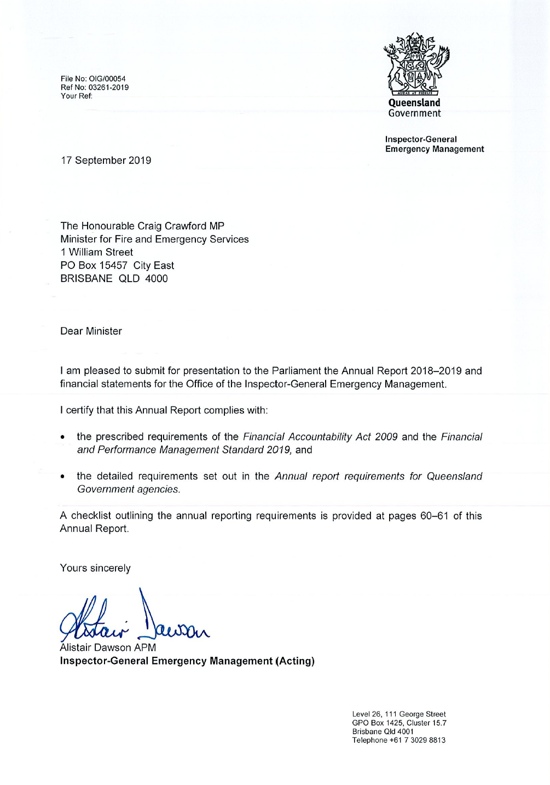

17 September 2019

The Honourable Craig Crawford MP

Minister for Fire and Emergency Services

1 William Street

PO Box 15457 City East

BRISBANE QLD 4000

Dear Minister

I am pleased to submit for presentation to the Parliament the Annual Report 2018–2019 and financial statements for the Office of the Inspector-General Emergency Management.

I certify that this Annual Report complies with:

the prescribed requirements of the *Financial Accountability Act 2009* and the *Financial and Performance Management Standard 2019,* and

the detailed requirements set out in the *Annual report requirements for Queensland Government agencies*.

A checklist outlining the annual reporting requirements is provided at pages 60–61 of this Annual Report.

Yours sincerely

Alistair Dawson APM

**Inspector-General Emergency Management (Acting)**

# Table of contents

[Letter of compliance 3](#_Toc20304967)

[Table of contents 4](#_Toc20304968)

[Inspector-General’s message 5](#_Toc20304969)

[Our organisation 6](#_Toc20304970)

[About the Office 6](#_Toc20304971)

[Operating environment 7](#_Toc20304972)

[Our performance: Non-financial 9](#_Toc20304973)

[Queensland Government’s objectives for the community 9](#_Toc20304974)

[Office’s strategic objectives 10](#_Toc20304975)

[2018–19 highlights 11](#_Toc20304976)

[Performance measures 21](#_Toc20304977)

[Our performance: Financial 23](#_Toc20304978)

[Summary of financial performance 23](#_Toc20304979)

[Summary of financial position 25](#_Toc20304980)

[Our governance: Structure and people 26](#_Toc20304981)

[Organisational structure 26](#_Toc20304982)

[Executive management 27](#_Toc20304983)

[Governance structure 28](#_Toc20304984)

[Our governance: Risk management and accountability 29](#_Toc20304985)

[Values and ethics 29](#_Toc20304986)

[Risk management 30](#_Toc20304987)

[Audit and risk committee 31](#_Toc20304988)

[Internal audit 33](#_Toc20304989)

[External scrutiny 34](#_Toc20304990)

[Information systems and recordkeeping 36](#_Toc20304991)

[Financial statements 37](#_Toc20304992)

[Certification of financial statements 54](#_Toc20304993)

[Independent Auditor’s Report 56](#_Toc20304994)

[Appendices 58](#_Toc20304995)

[Glossary 58](#_Toc20304996)

[Compliance checklist 60](#_Toc20304997)

# C:\Users\jhawthorne\AppData\Local\Microsoft\Windows\INetCache\Content.Word\IGEM_IainMackenzie_20170717_EPX0018_Webshot.jpgInspector-General’s message

The 2018–19 financial year was a rewarding year for the Office of the Inspector-General Emergency Management (the Office).

In the wake of a severe heatwave and bushfires in late 2018, and an unprecedented monsoon trough that affected more than half of the State in early 2019, the Office undertook two major reviews.

These reviews revealed the strength and capability of Queensland’s disaster management arrangements to meet the challenges of events of this nature. Importantly, these reviews also identified where lessons learnt through earlier events had been successfully applied.

Inspector-General   
Iain MacKenzie

Another key achievement for 2018–19 was the comprehensive refresh of the ground-breaking Emergency Management Assurance Framework (the Framework) and Standard for Disaster Management in Queensland (the Standard). The refresh included extensive consultation with around 100 stakeholders over 1000 hours to ensure that the Framework and the Standard remain relevant to the sector.

Akin to the findings of the Office’s key reviews this year, work to refresh the Framework and the Standard has been highly rewarding. These types of outcomes, in part driven by the work of my Office over the past five years, are the real test of success.

Another key headline activity for the Office and the disaster management sector during 2018–19 was the development of the Queensland Disaster Management Research Framework (the Research Framework).

Unique in Australia, the Research Framework has brought together people from State and local government and major universities in Queensland to drive a more collaborative approach to disaster management research. The Framework now includes a database of more than 150 researchers, and a Research Advisory Panel that will cooperatively identify and drive research priorities and activities into the future.

In 2018–19, the Office also:

* completed a review of the efficiency and effectiveness of recovery governance
* commenced a capability review of the Mount Isa Disaster District
* continued to progress the development of the Lessons Management Program
* published the Queensland Disaster Management Lexicon
* supported the award-winning Disaster Management Officers’ Network, which now boasts 112 members from 58 councils
* facilitated the review and assessment of the effectiveness of disaster management plans at local and district levels.

The commitment of the Office to collaborating and partnering with the sector to drive excellence in disaster management from the ground up is reflected in the results of the most recent customer satisfaction survey. Eighty three percent of respondents have told us that they were satisfied or very satisfied with the services and advice provided.

While this will be my last annual report as the Inspector-General, the Office is committed to taking the excellent work of 2018–19 to the next level in 2019–20 and striving to ensure the best possible disaster management arrangements exist for all Queenslanders.

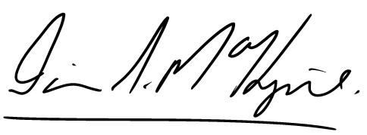

**Iain S MacKenzie AFSM**

**Inspector-General Emergency Management**

# Our organisation

## About the Office

Our vision: A catalyst for excellence in emergency management

Our purpose: To enable confidence in Queensland’s emergency management arrangements

The Office of the Inspector-General Emergency Management (the Office) was established as a public service office on 1 July 2014 under amendments to the *Disaster Management Act 2003*.

The role of the Office is to support confidence in Queensland’s emergency management arrangements.

The Office provides independent assurance and advice to the Government about Queensland’s emergency management arrangements. It also undertakes authoritative reporting to enhance accountability and improve outcomes for the community.

The Office does this by conducting reviews and system analysis to identify risks to emergency management planning, preparedness, response and recovery arrangements and by recommending evidence-based improvements.

The Office is located at Level 26, 111 George Street, Brisbane, Queensland 4000.

Our functions

Under the *Disaster Management Act 2003*, the Office’s functions include to:

* regularly review and assess the effectiveness of disaster management by the state, including the State Disaster Management Plan and its implementation
* regularly review and assess the effectiveness of disaster management by district and local groups, including district and local disaster management plans
* regularly review and assess cooperation between entities responsible for disaster management in the state, including whether the disaster management systems and procedures employed by those entities are compatible and consistent
* make disaster management standards
* regularly review and assess disaster management standards
* review, assess and report on performance by entities responsible for disaster management in the state against the disaster management standards
* work with entities performing emergency services, departments and the community to identify and improve disaster management capabilities, including volunteer capabilities
* monitor compliance by departments with their disaster management responsibilities
* identify opportunities for cooperative partnerships to improve disaster management outcomes
* report to, and advise, the Minister about issues relating to the above functions.

## Operating environment

Our strategic context

The Office operates in the context of Queensland communities that are geographically, economically and ethnically diverse.

Factors such as population growth, vulnerability to natural and human-caused disasters, and forecast increases in the complexity, frequency and severity of natural disasters due to climate change are key considerations for the Office. They continue to drive the Office to promote a coordinated strategic direction for emergency management in Queensland.

The Office draws on good practice, innovation and learning at all levels of Queensland’s disaster management arrangements - local, district and state - to support sustainable change in this context. Collaboration, cooperation, co-design and community-centric approaches that build local capability are also key.

Independent reviews conducted by the Office following major events such as cyclone, bushfire and flood contribute to continuous improvement in disaster management. These reviews are critical to providing an assurance of public safety.

Our key stakeholders

The Office works with local governments, state government agencies, non-government organisations and universities to improve disaster management outcomes for the community.

It seeks input from affected communities as part of its review activities.

It also collaborates with other jurisdictions on contemporary emergency management issues and practice.

Communication and engagement activities undertaken by the Office are based on four key principles:

* clear, accurate and timely communication
* accessibility and inclusiveness
* transparency
* measurable outcomes and evaluation.

The Public Safety Business Agency (PSBA) provides corporate services to the Office. This includes information and communication technology, finance, procurement, asset management, human resource and audit services.

Queensland Fire and Emergency Services (QFES) provides professional legal and multi-media services to the Office.

Services are delivered in accordance with service level agreements and catalogues that detail the relevant accountabilities of each agency.

Our key strategic risks

* Customer and stakeholder expectations - a failure to balance competing needs, caused by changing customer and stakeholder expectations, may diminish the Office’s ability to provide valued advice and assurance about disaster management effectiveness and outcomes.
* Changing hazard environment - limited opportunity to engage with emergency management partners, caused by a changing hazard environment and more frequent disasters, may reduce the Office’s ability to support action to keep communities safe.
* Technological change - inadequate monitoring of advances in emergency management service delivery, systems and platforms, caused by rapid technological change, may limit the Office’s ability to support collaboration between entities.

Our key strategic opportunities

* Balance - achieve a more effective balance between shared responsibility, clear accountability and outcome-focused performance across all tiers of government in the emergency management sector.
* Champion - actively champion collaboration, partnerships and authentic leadership across the emergency management sector.
* Empower - promote genuine community engagement and empowerment by emergency management entities.

Our key priorities in 2019–20

* Continuing to promote a coordinated strategic direction for emergency management in Queensland.
* Undertaking targeted reviews that identify risks and prioritise improvements in Queensland's emergency management arrangements.
* Providing system monitoring, analysis, oversight and assurance to build stakeholder capability to deliver their emergency management accountabilities.
* Leading the development of a system-wide lessons management program for disaster management in Queensland.
* Enabling a collaborative, sector-wide approach to disaster management research.

These priorities are aligned to the Office’s legislated functions and key activities in the *Queensland State Disaster Management Plan*.

There are no known changes to the operating environment of the Office for 2019–20.

# Our performance: Non-financial

## Queensland Government’s objectives for the community

The Queensland Government works closely with all Queenslanders to deliver its objectives for the community.

*Our Future State: Advancing Queensland’s Priorities* is a whole-of-government agenda to address areas of major challenge and community concern.

It comprises six high-level outcomes and thirteen specific priority targets*.*

The Office contributes to *Our Future State: Advancing Queensland’s Priorities:*

* *Keep communities safe* by reviewing and assessing the effectiveness of Queensland’s disaster management arrangements and recommending improvements
* *Be a responsive government* by identifying cooperative partnerships to support improved community outcomes.

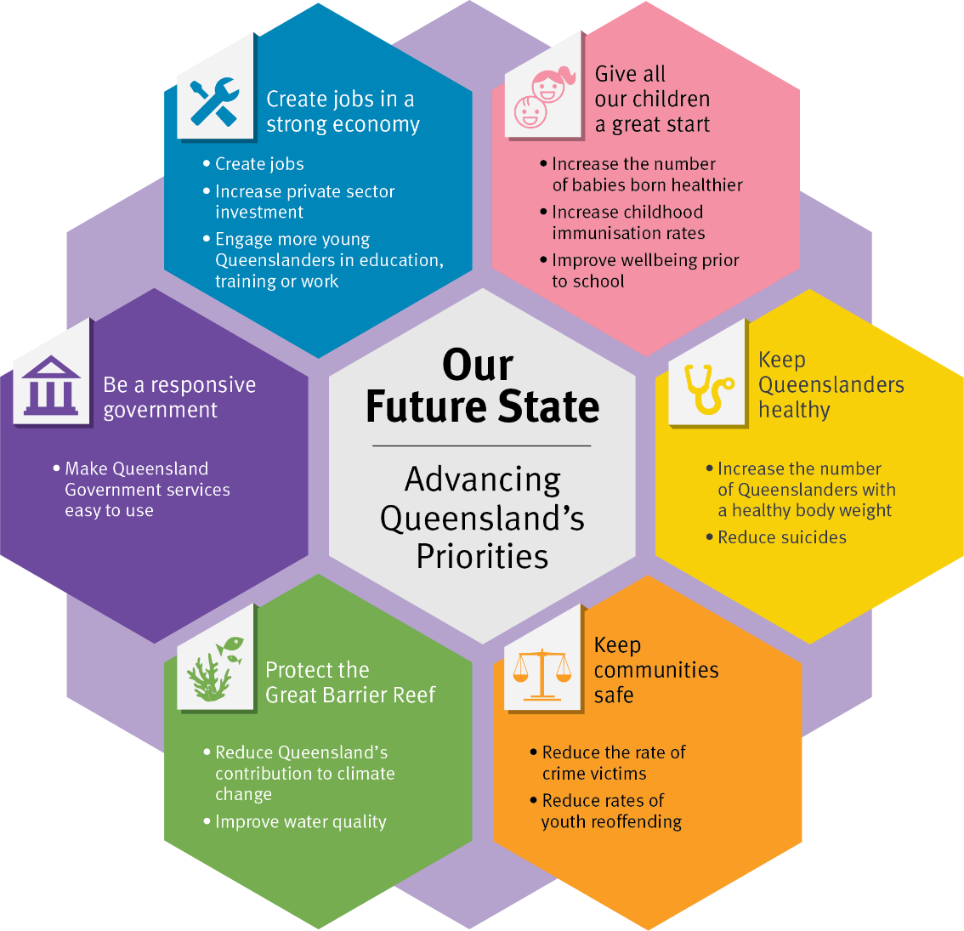

Create Jobs in a strong economy  
Create jobs  
Increase private sector investment  
engage more young Queenslanders in education training or work

Give All our children a great start

Increase the number of babies born healthier  
Increase childhood   
immunisation rates  
Improve wellbeing prior to school

Our future state

Advancing Queensland’s priorities

Be a responsive government

Make queensland government services easy to use

Protect the great barrier reef

Reduce queensland contribution to climate change

Improve water quality

Keep communities safe

Reduce the rate of crime victims

Reduce the rates of youth reoffending

keep[ Queenslanders healthy

Increate the number of Queenslanders with a healthy body weight

Reduce suicides

## Office’s strategic objectives

During the 2018–19 financial year, the Office focused on delivering three strategic objectives as outlined its *Strategic Plan 2018–22* (available at [www.igem.qld.gov.au](http://www.igem.qld.gov.au/)).

**Objective 1**  
Independent assurance and advice to Government, stakeholders and the community enhances strategic direction, accountability and outcomes in Queensland’s emergency management arrangements

**Strategies:**

* Promote a coordinated strategic direction for emergency management in Queensland
* Undertake targeted reviews that identify risks and prioritise improvements based on community outcomes
* Provide system analysis, oversight, monitoring and assurance that builds capability and empowers key stakeholders to effectively deliver their emergency management accountabilities and outcomes
* Adopt a collaborative approach to lessons management across the disaster management sector
* Design and embed contemporary assurance frameworks and tools that are valued by stakeholders and enable improved performance, evaluation and reporting.

**Objective 2**  
A culture of collaboration, improvement, excellence and innovation that challenges the emergency management sector to adapt to and explore emerging opportunities

**Strategies:**

* + Seek and harness trusted partnerships that promote collaboration, community-centric engagement, leadership and resilience
  + Connect and engage with key stakeholders through adaptable platforms, systems and processes that enable interoperability and good governance
  + Leverage current research, analysis and leading practice to inform evidence-based policy and advice.

**Objective 3**  
A diverse, forward looking, agile and engaged workforce

**Strategies:**

* + Actively champion inclusion and diversity
  + Foster a culture of service excellence and high-performance that models our values
  + Strengthen our workforce capability, knowledge management and use of common language.

## 2018–19 highlights

Strategic objective one

Independent assurance and advice to Government, stakeholders and the community enhances strategic direction, accountability and outcomes in Queensland’s emergency management arrangements

Emergent reviews

* Delivered: Two emergent reviews at the direction of the Queensland Government in response to significant natural disaster events:
* *2018 Queensland Bushfires Review Report 2: 2018–19*. This review assessed the effectiveness of preparedness activities and response to the major bushfires and heatwave that occurred across the State toward the end of 2018. The review report is available at [www.igem.qld.gov.au](http://www.igem.qld.gov.au/).
* *2019 Monsoon Trough Rainfall and Flood Review Report 3: 2018–19*. This review assessed the effectiveness of preparedness and response activity surrounding the monsoon trough rainfall and flood event that occurred in northern Queensland in January and February 2019. The review report is available at [www.igem.qld.gov.au](http://www.igem.qld.gov.au/).

Both reviews accepted public submissions and included community surveys to capture public opinion. The Inspector-General Emergency Management (IGEM) and Office staff also travelled to affected areas to directly consult with key stakeholders.

To inform the 2018 Queensland Bushfires Review, a nationally recognised research centre was engaged to explain the science behind the weather events and lessons from Australia and overseas.

To inform the 2019 Monsoon Trough Rainfall and Flood Review, an independent external firm with hydrology and flood management expertise was engaged to undertake a hydrological assessment of the Ross River Dam and aspects of flooding in Townsville.

Planned reviews

* Delivered: One planned review
* *Review - Efficacy of recovery governance Report 1: 2018–19*

This review was scheduled as part of the Office’s planned program of work in the 2017–18 financial year and was largely completed during this time. Due to an extended consultation period, the review was finalised in the first quarter of the 2018–19 financial year.

The review focused on identifying those aspects of recovery arrangements that could be enhanced leading to better local community recovery and outcomes.

The review report is available at [www.igem.qld.gov.au](http://www.igem.qld.gov.au/).

* In progress: Capability review of the Mount Isa Disaster District

The Office commenced a capability review of the Mount Isa Disaster District in late 2018.

This included data collection and engagement with the Mount Isa District Disaster Management Group and local disaster management groups in Boulia, Burke, Carpentaria, Cloncurry, Diamantina, Doomadgee, McKinlay, Mount Isa and Mornington Island.

The capability of the district and local groups was tested during the rainfall and flooding events of early 2019.

The Office’s 2018–19 planned program of work was affected by the natural disasters that impacted Queensland in late 2018 and early 2019. During this time the capability review of the Mount Isa Disaster District was paused so that the Office could redirect its efforts to ensure timely delivery of the emergent reviews of the bushfires and monsoon trough rainfall and flood event.

Other assurance activities

* Delivered: Refresh of the Emergency Management Assurance Framework (the Framework) including the Standard for Disaster Management in Queensland (the Standard)

The Framework and the Standard were developed in 2014 ‘for the sector, by the sector’.

The refresh was informed by more than 1000 hours of engagement. This included face to face consultation, six working groups, 108 responses to external surveys and insights captured over four years of application.

The Office is taking a phased approach to supporting the sector to transition to the refreshed Framework and Standard. This support will include providing resources and delivering workshops. Results of the Office’s 2019 customer satisfaction survey indicate that 68% of respondents are keen to understand the Standard more and apply it to their work.

The Framework and the Standard are available at [www.igem.qld.gov.au](http://www.igem.qld.gov.au/).

* Delivered: Annual assessment of the effectiveness of local and district disaster management plans

2018 was the fourth year that the Office has assessed district and local plans against the Standard through an analysis of online results and a sample of plans.

This assessment showed that overall, plans are ‘well-placed’ across all six shared responsibilities of the Standard. It also showed that local government and district group confidence has steadily improved since 2015.

Good practice examples have been shared with the sector so that councils can draw down learnings from each other’s experiences and incorporate applicable learnings into their plans.

* In progress: Development of a system-wide lessons management program for disaster management in Queensland

The importance of lessons management is highlighted in the *Queensland State Disaster Management Plan*.

It is a key part of continuous improvement in disaster management practice. Lessons management enables learnings from events, exercises and good practice to be identified, shared and embedded in the disaster management system.

The system-wide lessons management program is being co-designed with a working group of around 30 stakeholders in the disaster management sector. Other jurisdictions have also been consulted.

Lessons were recently identified and shared with the sector from the 2018 Queensland Bushfires Review and the 2019 Monsoon Trough Rainfall and Flood Review.

The Office’s forward program of work for 2019–20 includes delivery of planned reviews and assurance activities that were paused in 2018–19.

Strategic objective two

A culture of collaboration, improvement, excellence and innovation that challenges the emergency management sector to adapt to and explore emerging opportunities

Collaboration with local government

* Ongoing: Disaster Management Officers’ Network

The Office continued to support a network of disaster management officers and local disaster coordinators from councils across Queensland.

This peer-driven group, known as the Disaster Management Officers’ Network, comprised 112 officers from 58 councils across the state, represents about 75% of Queensland’s councils. Established five years ago, it is the first statewide network of disaster management practitioners from councils ever developed in Australia.

The network and its activities help to collaboratively strengthen capability and operational capacity in disaster and emergency management. In 2018–19, the network was supported by the Office hosting nine teleconferences, with members presenting case studies, workshopping issues and developing themes for further discussion at the annual forum.

The fourth annual network forum was held on the Gold Coast in early May 2019. The forum attracted 68 representatives from local governments across the state. This year, representatives from QFES, Queensland Reconstruction Authority, the Office of the Information Commissioner, Australian Broadcasting Corporation, Quandamooka Yoolooburrabee Aboriginal Corporation, Volunteering Queensland and Team Rubicon Australia delivered presentations and participated in discussion panels.

The network supported the engagement of local councils in key initiatives of the Office such as the recent refresh of the Framework and the Standard, the ongoing program of capability reviews and work to develop a lessons management program.

Cooperative partnerships

* In progress: Queensland Disaster Management Research Framework

The Queensland Disaster Management Committee (QDMC) has identified the Disaster Management Research Framework (the Research Framework) as one of its priorities in the *Queensland State Disaster Management Plan*.

Collaborative development and promotion of research for Queensland’s unique context was progressed as part of this peer-driven Research Framework through:

* developing a coordinated approach to undertaking, managing and sharing research
* establishing strategic research priorities for the disaster management sector
* promoting and facilitating engagement between government and the tertiary sectors
* supporting the transfer of research findings into practice.

A Research Advisory Panel was established in November 2018 to support the Research Framework. This panel includes representatives from state government agencies, local government and Queensland universities. It met four times during 2018–19 to shape the direction of the Research Framework.

A Research Community of Practice hosted by the Office continued to grow. A register has been developed of more than 150 university researchers specialising in disaster and emergency management from a broad range of disciplines. These disciplines include architecture, engineering, economics, creative industries and journalism.

Collaboration on specific projects includes:

* a proof-of-concept study with Griffith University on the use of a community practice model to engage local food network providers in disaster management
* implementation of the National Gender and Emergency Management Guidelines in Queensland in partnership with the Australian Red Cross
* initial scoping on a project examining how Indigenous communities use intergenerational Dreamtime and Creation stories to share learnings about disasters
* mentoring local government disaster management officers undertaking postgraduate studies.
* Ongoing: Inspector-General Emergency Management Advisory Panel

The Office hosted three IGEM Advisory Panel meetings in 2018–19.

This panel, established in February 2016, continued to provide stakeholder guidance to the IGEM. Input was provided on a range of issues including disaster management plan assessments, data integration and the Office’s strategic direction.

Panel members included representatives from state agencies, Brisbane City Council, Australian Red Cross and Queensland universities.

Excellence through local, state and national engagement

* Ongoing: Active participation in committees and working groups:
* Brisbane River Strategic Floodplain Management Working Group
* Flood Warning Consultative Committee
* Ready and Resilient Working Group
* Disability Inclusive Disaster Risk Reduction Advisory Group
* Community Recovery Forum Reference Group
* Disaster Management Coordination Working Group
* Queensland Heatwave Risk Assessment Interdepartmental Project
* IGEM Assurance Collaborative to support inter-jurisdictional sharing of lessons, evaluation and assurance activities, research and innovative practice
* Contributed to the *National Warnings Framework Working Group development of the Public Information and Warnings Handbook (Handbook 16 of the Australian Disaster Resilience Handbook Collection)* released in November 2018
* National Resilience Taskforce’s inter-jurisdictional and multi-sector Partnership Group development of the *Report Profiling Australia’s Vulnerability: the interconnected causes and cascading effects of systemic disaster risk* and the accompanying set of resources: *Guidance for strategic decisions on climate and disaster risk*
* Observer: QDMC and State Disaster Coordination Group meetings.
* Delivered: Attendance at exercises and debriefs:
* Brisbane Disaster District in July 2018
* Mount Isa Disaster District in July 2018
* Townsville Disaster District in July 2018
* Sunshine Coast Disaster District in August 2018
* Exercise Torres in August and September 2018
* Queensland Health strawberry contamination incident debrief in December 2018
* Queensland Health post-incident review workshop in May 2019
* Sunshine Coast Aged Care Forum in May 2019
* Ipswich Local Disaster Management Group in June 2019.

Thought leadership

* Delivered: Queensland Disaster Management Lexicon

The Queensland Disaster Management Lexicon (the Lexicon) was published in August 2018.

The Lexicon contains more than 100 terms. It will enable better interoperability across state agencies, local councils and non-government organisations through the use of a shared language.

The Office also contributed to the review of the Australian Disaster Resilience Glossary coordinated by the Australian Institute for Disaster Resilience.

* Delivered: Presentations at key conferences:
* Lessons Management Forum, Victoria, July 2018
* Australian Evaluation Society Conference, Tasmania, September 2018
* Penang Disaster Management Workshop, Malaysia, October 2018
* World Association for Disaster and Emergency Medicine Workshop, Queensland, May 2019
* 12th Australasian Natural Hazards Management Conference, Canberra, June 2019.
* Delivered: Publications:
* Disaster Management Officers’ Network article published in the Australian Journal of Emergency Management in April 2019
* Issued five editions of IGEM Connect to around 1400 stakeholders (available at [www.igem.qld.gov.au](http://www.igem.qld.gov.au/)).

Culture of innovation

* In progress: Adaptable platforms, systems and processes

The Office continued to connect and engage with key stakeholders through adaptable platforms, systems and processes.

For the third year, the Office put up a challenge and mentored Queensland participants in the annual GovHack competition. The 2018 challenge was around resilience, ‘How might we understand what makes communities strong in disasters?’. The challenge attracted entries from across the state, involved ideas from variable message signs to interactive games, and was won by a team from Rockhampton.

The Office also participated in the Open Data Senior Officers’ Working Group and Innovation Champions Network.

To ensure a contemporary online presence, a refresh of the Office’s website was significantly progressed. This refresh is on track for completion in the second quarter of the 2019 financial year.

The Office also explored a range of options to transition its existing customer relationship management system to a new platform.

To support more integrated strategic, financial, operational and performance planning processes, the Office:

* implemented project management software and business intelligence tools. These tools will facilitate better project planning, resource management, tracking, monitoring and reporting against the Office’s key projects, review and assurance activities. Once fully implemented, the software and tools will ensure that more robust systems are in place to capture accurate and single point-of-truth data to inform performance reporting
* continued to embed the Nexus Human Capital Management system, Aurion and Fraedom in its day-to-day business processes to create efficiencies in the delivery of operational human resource and financial activities.

An employee opinion survey (Working for Queensland survey) conducted in September 2018 achieved positive results for innovation (85%).

Strategic objective three

A diverse, forward looking, agile and engaged workforce

Strategic workforce planning

* Ongoing: Workforce Strategy 2019–23

The Office’s Workforce Strategy was refreshed and shared with staff in January 2019.

Key workforce priorities for the Office for 2018–19 included:

* promoting leadership mobility and development, including succession planning
* implementing a contemporary performance review and development planning process
* promoting and modelling practices and programs that support flexible work practices, safety, health and wellbeing and domestic and family violence prevention
* embedding the Office’s commitment to a diverse workforce
* strengthening workforce capability.

The Office developed a Workforce Competency Framework and invested in staff development to ensure expertise, skills and knowledge remain contemporary in a changing emergency and disaster management environment (page 18 refers).

The Office participated in the 2018 sector-wide Working for Queensland survey achieving a 100% response rate. Results for agency engagement (82%) improved from 2017. The Office’s result for organisational leadership (70%) declined slightly from 2017, however this result was well above that for the Queensland public sector.

Survey results were explored in staff workshops and activities progressed to facilitate workplace improvements. These activities included providing ongoing support for leadership and professional development activities, supporting flexible work practices and staff engagement in business and project planning.

No early retirement, redundancy or retrenchment packages were paid to employees of the Office during the period 1 July 2018 to 30 June 2019.

Inclusion and diversity

* Ongoing: Cultural Capability Action Plan 2019–21

The Office’s Cultural Capability Action Plan was refreshed and shared with staff in December 2018.

Cultural awareness and capability building were embedded into the Office’s business by:

* participating in NAIDOC week activities and the sector-wide Cultural Capability Community of Practice
* meeting with Aboriginal leaders and Torres Strait Islander leaders and community members as part of reviews, evaluation activities, research projects and forums
* promoting cultural immersion activities to staff.
* Delivered: Visible commitment to women

The Office was proud to again be involved in the annual Public Safety International Women's Day event on 8 March 2019. This event, attended by 800 staff from across the public safety and integrity agencies, celebrated the work of women. It provided an opportunity for staff to come together to network, learn, raise awareness and celebrate women’s achievements.

The theme of the event was ‘You are enough: Believe in yourself and your journey’.

The event raised $33,000 for Hummingbird House.

The IGEM presented a Champion of Change Award to two outstanding women at this event:

* Ms Elyshia Ray, National Projects Officer Australian Red Cross, won the award for her work to ensure community members and those who assist during times of disaster are well equipped to face the challenges of domestic and family violence (DFV).
* Ms Carla Adams, Emergency Management Coordinator for Mackay, QFES, was highly commended for encouraging and supporting women in the sector through mentoring and personally demonstrating her leadership when faced with challenging situations.
* Delivered: Visible commitment to domestic and family violence prevention

The Office continued to build on its White Ribbon Accreditation by taking active steps to prevent and respond to violence against women and supporting employees affected by DFV by:

* participating in events and initiatives to promote gender equity and the prevention of violence against women
* partnering with the PSBA and Queensland Police Service (QPS) to host a Trivia Night in July 2018 to support White Ribbon Australia
* working with the PSBA to support Rizeup Australia’s at Home Program. Staff donated items and helped to set up a home for a family fleeing DFV
* attending a Candlelight Vigil on 1 May 2019 and participating in the annual Darkness to Daylight Challenge, to raise community awareness and support for those affected by DFV
* partnering with the Australian Red Cross to implement the National Gender and Emergency Management Guidelines in Queensland.

Specialised DFV counselling support, referrals and assistance was made available to staff via a dedicated DFV line. Advice was also available to managers to assist them to support staff if affected by DFV.

An employee opinion survey (Working for Queensland survey) conducted in September 2018 indicated that all staff in the Office were aware of workplace policies designed to support employees affected by DFV. Further, 93% of non-managers felt confident that they could effectively refer a colleague affected by DFV to appropriate support.

Workforce capability

* Delivered: Leadership and management development

Investment in staff leadership development was realised by:

* supporting staff to participate in the Executive Challenge Academy course
* promoting the *Leadership Competencies for Queensland* in line with the whole-of-government public sector approach by including the behaviours in role descriptions and performance and development plans
* supporting emerging leaders to attend professional development activities such as conferences, seminars and facilitation skills training.
* Delivered: Workforce Competency Framework

The Office developed its own Workforce Competency Framework in 2018–19.

This framework includes the *Leadership Competencies for Queensland*, public sector values, and Office-specific functional competencies focused on delivering excellence in emergency management. The framework will assist the Office to attract, retain and maintain the knowledge, skills and values it needs to deliver its legislated functions and strategic objectives.

Skills and expertise were built through tailored courses such as root cause analysis and government investigations training, and by participating in secondments with other agencies.

The Office continued to encourage open conversations between staff and their direct supervisors about career aspirations and development opportunities through the performance and development planning process. This process is refreshed on an annual basis to ensure it remains contemporary.

* Ongoing: Corporate induction

The Office continued to recognise induction as an important avenue to welcome new starters to the Office and share vital corporate knowledge. The Office participated in the quarterly induction program coordinated by the PSBA. This program includes a site visit to a public safety agency to facilitate a greater understanding of the business operations of frontline agencies.

The program covered a broad range of topics including the Office’s strategic objectives, conditions of employment, employee entitlements, workplace conduct and performance, safety and wellbeing, and diversity and inclusion. It also provided an opportunity for attendees to develop networks.

Workplace and staff safety, health and wellbeing

* Delivered: Visible commitment to safety, health and wellbeing

The Office continued to foster a supportive working environment to assist staff to maintain health and wellbeing by:

* issuing a Health, Safety and Wellbeing Statement to demonstrate a commitment to providing a work environment that is free from harm
* participating in the QPS Influenza Vaccination program
* promoting health and wellbeing initiatives such as mental health, men’s health, women’s health, illness and injury management
* sharing safety alerts containing important prevention and control messaging on issues such as communicable diseases in flooded areas
* promoting and providing access to staff and their immediate family members to professional, confidential and independent counselling through the Employee Assistance Program to support emotional, physical and financial wellbeing
* actively promoting and supporting access to flexible work practices such as flexible work hours, telecommuting, part-time work, distributed work centre arrangements and leave at half pay.

An employee opinion survey (Working for Queensland survey) conducted in September 2018 indicated that 79% of staff were using flexible workplace options.

The PSBA supported the Office in delivering its commitment to workplace health and safety. The safety and wellbeing intranet site was redesigned to provide staff with better access to information. Work is progressing on the development of a safety management system for the Office to be implemented in the 2019–20 financial year.

The Office’s injury management cases are managed by the PSBA Safety and Wellbeing team. A Workplace Rehabilitation Policy and Injury/Illness Management Standard guide this approach. Injury management support mechanisms are available to assist early intervention.

An employee opinion survey (Working for Queensland survey) conducted in September 2018 reflected improved results for the Office for workload and health since 2017.

In support of the Office’s focus on creating a fair and positive workplace culture, the PSBA provided industrial and employee relations support to management and staff. This included conducting enterprise bargaining negotiations with relevant unions and providing general interpretation of legislative and industrial instruments.

Service excellence

* In progress: Assurance and Excellence Development Program refresh

The Assurance and Excellence Development Program (AEDP) is an internal tool that guides how the Office conducts its core business of review and assurance activities.

In 2018–19, the Office commenced a refresh of the AEDP. The refresh will better support the delivery of the Office’s assurance activities and will seek to strengthen the Office’s workforce capability and knowledge management.

The refresh has adopted a ‘for the Office, by the Office’ approach to the AEDP. This is consistent with the Office’s ‘for the sector, by the sector’ commitment, as evident in the process used to develop the Framework and the Standard.

The AEDP has recently been rebranded as the IGEM Business Excellence Program (IGEMx) to emphasise the promotion of excellence in the Office’s business practices. The first phase of IGEMx is scheduled to be delivered by the end of September 2019.

To assess the Office’s service culture, an annual customer satisfaction survey was conducted in March to April 2019. The Office achieved an overall customer satisfaction rating of 83%. This is higher than the result achieved in 2018 (81%) and exceeds the Office’s performance target (80%) (pages 21 to 22 refer).

The Office’s ability to be helpful, supportive and display a cooperative approach was a key reason for customer satisfaction. Satisfaction with Office staff continued to be high with many respondents satisfied that staff were professional (94%), approachable (91%) and knowledgeable (84%).

Staff have confirmed the value of ongoing stakeholder engagement in all aspects of the Office’s work to support excellence in emergency management.

## Performance measures

The Office’s service area objective is ‘Independent Assurance and Advice to Improve Emergency Management’.

The Office provides independent assurance and advice about Queensland’s emergency management arrangements and authoritative reporting to enhance accountability and improve outcomes for the community.

The Office undertakes a range of assurance activities and system analysis to identify risks to emergency management planning, preparedness, response and recovery arrangements and recommends evidence-based improvements. The most robust assurance activity is a tier three review that has significant depth and rigour and provides a higher level of confidence in the disaster management matter being assessed.

Key performance measures for the Office in the Service Delivery Statement (SDS) 2018–19 are below:

|  |  |  |  |
| --- | --- | --- | --- |
| Service area: Independent Assurance and Advice to Improve Emergency Management | | | |
| Performance measure (service standard) | **Notes** | **2018–19 Target/Estimate** | **2018–19 Actual** |
| Average cost per tier three review ($’000) | 1, 2 | 200 | 482 |
| Customer satisfaction (Overall) | 3 | 80% | 83% |

Notes:

1. This service standard measures the average cost to complete a tier three review. Included in this measure are costs incurred by the Office in undertaking tier three reviews such as staff salaries, travel, accommodation, venue hire, contractors and legal advice. It is normal for the methodology, scope and depth of each tier three review to differ. Tier three reviews undertaken by the Office as part of its planned program of work have standard planning parameters. In comparison, reviews directed by Government in response to disaster events are generally broader in scope due to their emergent nature and attract additional resources and cost. These factors may impact on the Actual result from year to year.
2. The 2018–19 Actual includes the cost of completing two reviews. These reviews were emergent reviews (2018 Queensland Bushfires Review and 2019 Monsoon Trough Rainfall and Flood Review) undertaken at the direction of Government in response to an emerging event and included a community survey of affected areas. To inform the 2018 Queensland Bushfires Review, the Office engaged the services of a nationally recognised research centre to explain the science behind the events and lessons from Australia and overseas. To inform the 2019 Monsoon Trough Rainfall and Flood Review, the Office engaged an independent external firm with hydrology and flood management expertise. The need to conduct emergent reviews is not known and therefore not included in the 2018–19 Target/Estimate. The Review of the efficacy of recovery governance was scheduled for completion in the 2017–18 financial year and included in the SDS for 2017–18. The Capability review of the Mount Isa Disaster District was not completed in the 2018–19 financial year and is scheduled for completion in the 2019–20 financial year.
3. This service standard measures overall satisfaction with the Office. It is measured as part of an annual customer survey. Customers include the Minister and state and local government stakeholders with a role in disaster and emergency management. It is calculated by the number of respondents who indicated they were either 'very satisfied' or 'satisfied' (on a five-point scale ranging from 'very dissatisfied' to 'very satisfied') with the service and advice provided by the Office, represented as a percentage of the total number of responses received.

Key performance measures for the Office in the *Strategic Plan 2018–22* are below:

|  |  |  |  |
| --- | --- | --- | --- |
| Performance measure | Notes | 2018–19 Actual | 2017–18 Actual |
| Customer satisfaction with Office of the IGEM reviews | 1 | 58% | 75% |
| Customer perceptions of Office of the IGEM platforms | 2 | 84% | 88% |
| Customer satisfaction with Office of the IGEM information and advice | 3 | 67% | 73% |
| Customer satisfaction with Office of the IGEM staff | 4 | 94% | 91% |
| Staff perceptions of organisational leadership | 5 | 70% | 76% |
| Staff perceptions of agency engagement | 5 | 82% | 81% |
| Staff perceptions of use of flexible work arrangements | 5 | 79% | 73% |

Notes:

1. Number of respondents who indicated that they were either ‘very satisfied’ or ‘satisfied’ (on a five-point scale ranging from ‘very dissatisfied’ to ‘very satisfied’) that advice provided as a result of a review was useful, represented as a percentage of the total number of responses received. Measured as part of an annual customer survey.
2. Number of respondents who indicated that they ‘strongly agree’ or ‘agree’ (on a five-point scale ranging from ‘strongly disagree’ to ‘strongly agree’) that the content of the Office’s website is informative, represented as a percentage of the total number of responses received. Measured as part of an annual customer survey.
3. Number of respondents who indicated that they were either ‘very satisfied’ or ‘satisfied’ (on a five-point scale ranging from ‘very dissatisfied’ to ‘very satisfied’) that information or advice given helped improve their business, represented as a percentage of the total number of responses received. Measured as part of an annual customer survey.
4. Number of respondents who indicated that they were either ‘very satisfied’ or ‘satisfied’ (on a five-point scale ranging from ‘very dissatisfied’ to ‘very satisfied’) that the Office’s staff were professional. Measured as part of an annual customer survey.
5. This measure assesses aspects of workplace climate and use of flexible work options in the Office. Measured as part of an annual Working for Queensland survey.

# Our performance: Financial

## Summary of financial performance

The following table summarises the operating result and financial position for the Office for 2018–19 and the previous financial year.

|  |  |  |
| --- | --- | --- |
| Statement of comprehensive income | 2018–19  $’000 | 2017–18  $’000 |
| Total income from continuing operations | 4,867 | 4,925 |
| Total expenses from continuing operations | 4,864 | 4,923 |
| Other comprehensive income | Nil | Nil |
| Total comprehensive income | **3** | **2** |
| Statement of financial position |  |  |
| Total assets | 1,645 | 1,598 |
| Total liabilities | 480 | 436 |
| Net assets (equity) | **1,165** | **1,162** |

Financial Performance

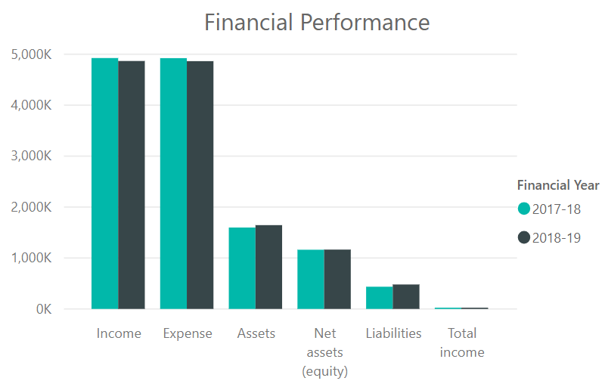

Income Expense Assets Net assets (equity) Liabilities Total income

For 2018–19, the Office received income from continuing operations of $4.867 million and incurred total expenditure from continuing operations of $4.864 million. This was comprised predominantly of:

Income

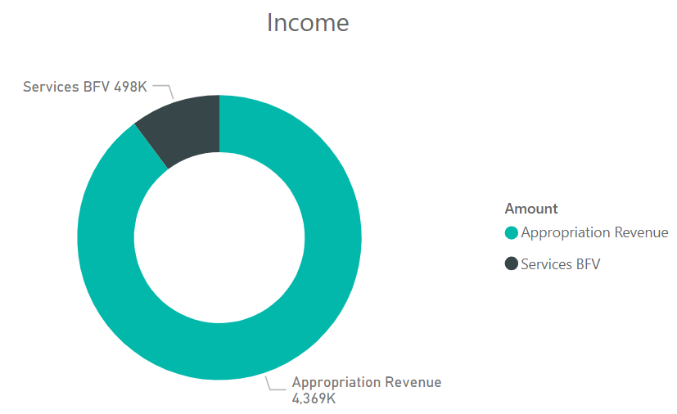

Amount

Appropriation revenue

Services BFV

Appropriation revenue

4,369l

Services BFV 498k

Expenses

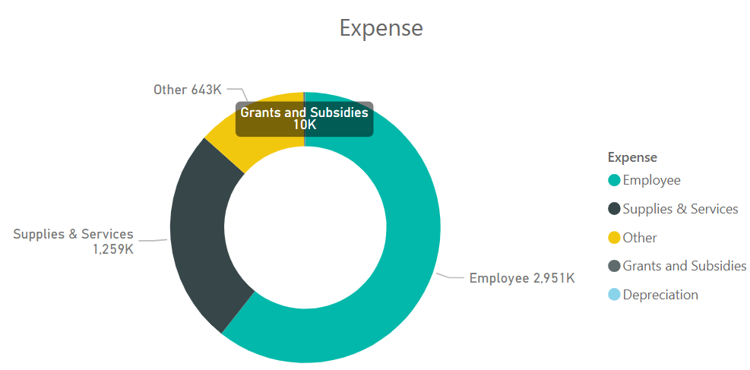

Supplies & Services  
1,259k

Other 643k

Employee 2,95k

Expense

Employee

Supllies & services

Other

Grants and subsidies

depreciation

Note: Other expenses – refer to Note 8 (page 13) of the Financial statements on page 49 of this report

Income and expenses from continuing operations

The Office is responsible for providing the Minister for Fire and Emergency Services, government and the people of Queensland an assurance of public safety. It does this through the establishment and implementation of an assurance framework to direct, guide and focus the work of all agencies, across all tiers of government to the desired outcomes of the disaster and emergency management arrangements for Queensland.

The Office is funded to deliver the above services predominantly through parliamentary appropriations. The Office is also supported by the PSBA which provides corporate support services to the entity. The value of the services received is recognised as income and as an expense in the statement of comprehensive income.

## Summary of financial position

The Office was in a positive financial position at the end of the 2018–19 financial year. The total equity/net assets of the Office at the end of 2018–19 was $1.165 million. This was comprised of:

Assets

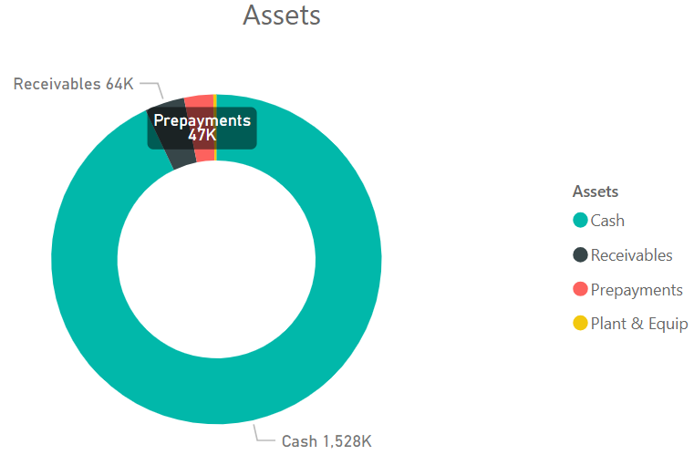

Receivables 64k

Assets

Cash

Receivables

Prepayments

Plant & equip

Cash 1,528k

Liabilities

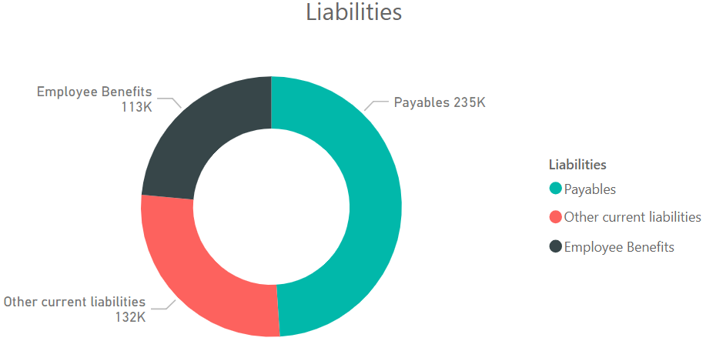

liabilities

Payables

Other current liabilities

Employee benefits

Other current liabilities 132k

Employee benefits 113k

Payables 235k

There were no significant events after balance date that could be expected to impact the operating result for the Office for 2018–19.

# Our governance: Structure and people

## Organisational structure

The IGEM reports to the Honourable Craig Crawford MP, Minister for Fire and Emergency Services.

At 30 June 2019, the Office was comprised of three key teams: Assurance and Evaluation; Research and Engagement; and Governance and Reporting.

The Assurance and Evaluation team develops, conducts and delivers reviews, lessons, assurance and evaluation frameworks, projects and activities. This team also provides system analysis and monitoring to build stakeholder capability in disaster management and ensure compliance with the legislated functions of the Office.

The Research and Engagement team develops, builds and delivers strategic partnerships, communication, research and engagement activities across a broad range of stakeholders. Stakeholders include all levels of government, tertiary and non-government organisations and the community.

The Governance and Reporting team develops, coordinates and delivers internal strategy, planning, performance, reporting and governance activities for the Office.

From 1 July 2018 to 31 December 2018, the Office was comprised of four key teams and four Directors: Interoperability and Innovation; Standards, Best Practice and Research; Community and Stakeholder Engagement; and Performance, Reporting and Policy Analysis.

The Office’s structure and executive management roles were realigned in January 2019 to better support service delivery.

The total number of Full-Time Equivalent (FTE) staff for the Office was 20.06 as at 30 June 2019.

The Office’s separation rate for permanent staff only (excludes contract staff) for the period 1 July 2018 to 30 June 2019 was 21%.

Further information on the Office’s human resources is available under the 2018–19 highlights (pages 16 to 20 refer).

## Executive management

At 30 June 2019, key executives were:

Iain MacKenzie AFSM. MLshipMgt (Policing), Inspector-General of Emergency Management

The IGEM leads the Office to provide assurance and advice to enable confidence in Queensland’s disaster and emergency management arrangements. The Office reviews and assesses the effectiveness of disaster management at the local, district and state level, works with agencies to improve Queensland’s disaster management arrangements, and identifies opportunities for cooperative partnerships.

Prior to Iain’s appointment as IGEM, he was the Deputy Commissioner of the former Queensland Fire and Rescue Service and served in the fire service for over 32 years. Iain holds a Masters Degree in Leadership and Management, is a graduate of the Institute of Fire Engineers and has attended the United States National Fire Academy Executive Fire Officer Program. Iain was awarded the Australian Fire Service Medal in 2006.

Mike Shapland MBE. MBA, Executive Director, Assurance and Evaluation

The Executive Director, Assurance and Evaluation leads review, lessons, assurance and evaluation projects and activities. This role oversights system analysis and monitoring to build stakeholder capability in disaster management and ensure compliance with the legislated functions of the Office.

Mike is a graduate of the Royal Military Academy, Sandhurst, the British Army’s Technical and General Staff courses and Griffith University’s Master of Business Administration program. Mike was awarded Member of the Order of the British Empire in the United Kingdom’s 1997 New Year’s Honours List.

Sarah March, Director, Governance and Reporting

The Director, Governance and Reporting leads the development, coordination and delivery of internal strategy, planning, performance, reporting and governance activities for the Office. The role acts as a liaison point with the PSBA and other key agencies in relation to service delivery and reporting.

Sarah holds a Bachelor of Arts (Psychology) and post graduate qualifications in Psychology.

Nicola Moore, A/Director, Research and Engagement

The A/Director, Research and Engagement leads the development of strategic partnerships and research, engagement and communication activities for the Office across a broad range of stakeholders.

Nicola holds a Bachelor of Applied Science, post graduate qualifications in Applied Science and Public Sector Management and a Master of Education.

From 1 July 2018 to mid-June 2019, Phil Nickerson was engaged in the Director, Research and Engagement role. Phil holds a Bachelor of Business (Communications) and a Bachelor of Business (Accountancy).

## Governance structure

The Office’s governance structure includes the:

* Executive Management Committee (EMC)
* PSBA and IGEM Audit, Risk and Compliance Committee.

The EMC is the key leadership group for the Office.

The EMC provides leadership and direction on strategic and operational issues. It ensures activities are carried out efficiently, effectively and economically in line with the Office’s vision, purpose and strategic objectives.

In 2018–19, the EMC provided strategic oversight of the Office’s reviews, assurance activities and key projects relating to research, stakeholder engagement and reporting.

At 30 June 2019, Iain MacKenzie was the Chair of the EMC. Members comprised those key executives listed on page 27.

The EMC meets monthly (unless otherwise determined by the Chair).

During 2018–19, the EMC met eleven times.

Further information on the PSBA and IGEM Audit, Risk and Compliance Committee can be found on pages 31 to 32.

# Our governance: Risk management and accountability

## Values and ethics

The Office’s values align with the Queensland Public Service values.

**** **** **** **** ****

Customers first Ideas into action Unleash potential Be courageous Empower people

These values inform the operations of the EMC, the day-to-day activities of the Office through the AEDP, and the Office’s performance and development planning process.

The Office complies with the *Code of Conduct for the Queensland Public Service*.

The induction program for new starters to the Office includes information about negative workplace behaviours, and an overview of the *Code of Conduct for the Queensland Public Service*. In 2018–19, the PSBA Conflict Management Services unit delivered sessions on workplace behaviours to employees of the Office.

The PSBA Employee Relations unit assesses complaints about the conduct of staff and volunteers of the Office:

* complaints are assessed in accordance with the PSBA and IGEM *Management of Complaints about Employees, Volunteers and Contractors Policy* and *Procedure*
* certain categories of complaints are formally investigated by the unit, whilst others will be referred to management for action, often with the unit’s oversight
* matters and complaints assessed by the unit are classified in accordance with the Public Service Commission *Managing employee complaints* (Directive 02/17).

The unit also:

* records all complaints of Corrupt Conduct and of Conduct and Performance Excellence (CaPE) 2 and 3
* acts as the central liaison for the Crime and Corruption Commission (CCC) and the Queensland Ombudsman, and in the discharging of the statutory obligations under the *Crime and Corruption Act 2001* for the Office
* provides oversight of the Public Interest Disclosure framework and provision of assistance to the Office in fulfilling its statutory obligations under the *Public Interest Disclosure Act 2010*
* coordinates requests for Internal Review lodged by persons dissatisfied with the way their complaints have been handled by the agency.

## Risk management

The Office’s approach to managing risk and fraud is governed by the:

* Risk Management Framework and Guide to Strategic and Operational Risk Management
* Fraud and Corruption Prevention and Control Policy and Plan.

During 2018–19:

* the Office’s Risk Management Framework and Guide to Strategic and Operational Risk Management were updated and shared with all staff
* a fraud and corruption risk assessment workshop was held in October 2018
* strategic risks and opportunities were refreshed during the development of the Office’s *Strategic Plan 2019–23*
* the EMC regularly monitored and reviewed strategic and project risks, challenges to the operating environment and mitigation activities
* project management software was implemented and applied to the 2018 Queensland Bushfires Review and the 2019 Monsoon Trough Rainfall and Flood Review to support operational and project planning, risk identification and assessment, resource allocation, monitoring and reporting
* work continued to leverage business intelligence tools to support accurate, timely and single point-of-truth access to data and information.

The Office will continue to mature its risk management approach, policies and systems to ensure it remains well placed to identify and address risk in a contemporary emergency management context.

## Audit and risk committee

The Public Safety Portfolio Audit and Risk Committee (PSP ARC) was established under, and operated in accordance with, the terms of its charter which was developed in line with Queensland Treasury’s *Audit Committee Guidelines: Improving Accountability and Performance*; the *Financial and Performance Management Standard 2019* and the *Financial Accountability Act 2009*. The committee reviews the charter annually to ensure consistency with the committee’s authority, objectives and responsibilities.

The PSP ARC provided independent assurance on audit functions for the PSBA partner agencies, including the Office and oversight and assurance over the effectiveness, efficiency and economy of the Office’s and PSBA’s risk, control and compliance frameworks. To ensure strong governance across the public safety agencies, advice of material issues was provided to the audit, risk and compliance committees of the QPS and QFES as and when relevant.

The committee was chaired by an independent external member. Each public safety partner agency was represented by one member. The Chair could invite or give approval for other persons to attend a committee meeting.

In August 2018, the committee was renamed the Public Safety Agencies Audit, Risk and Compliance Committee (PSA ARCC) to reflect the broader public safety agencies coverage of the committee, and to explicitly capture compliance in the committee’s considerations.

Prior to a revision of the committee’s charter on 11 January 2019, the committee met on two occasions.

On revision of the committee’s charter, the committee was renamed and repurposed as the PSBA and IGEM Audit, Risk and Compliance Committee (PSBA and IGEM ARCC). Part of this revision was a change in the membership composition, which included the cessation of QPS and QFES representation, the addition of a second independent member and a staff representative rotated between the Office and PSBA at each membership term. Currently this position is occupied by a PSBA staff representative.

The purpose of the PSBA and IGEM ARCC is to provide oversight of audit, risk and management compliance activities related to PSBA and the Office, including:

* their risk, control and compliance frameworks
* their external accountability responsibilities as prescribed by applicable legislative and regulatory frameworks
* other matters considered to be within the committee’s responsibilities as they relate to the PSBA and the Office.

From 11 January 2019 to 30 June 2019, the committee met on three occasions.

The independent external Chair received $7,016.59 (including GST) in remuneration for services provided to the PSA ARCC to 10 January 2019 and $6,184.73 (including GST) in remuneration for services provided to the PSBA and IGEM ARCC from 11 January 2019 to 30 June 2019. The second independent member of the PSBA and IGEM ARCC received $2,037.29 (including GST) for services provided from date of appointment on 22 February 2019 to 30 June 2019. There were no other on-costs incurred.

Committee Members – PSA ARCC

* Marita Corbett, Chair (Independent Chair)
* Geoff Waite, Executive General Manager, Risk and Intelligence, Queensland Treasury
* Tracy Linford APM, Deputy Commissioner, Strategy, Policy and Performance, QPS
* Doug Smith APM, Deputy Commissioner, Chief Strategy Officer, Strategy and Corporate Services, QFES
* Iain MacKenzie AFSM, Inspector-General Emergency Management
* Peter Griffin, Chief Operating Officer, PSBA.

Committee Members – PSBA and IGEM ARCC (from January 2019)

* Marita Corbett, Chair (Independent Chair)
* Geoff Waite, Executive General Manager, Risk and Intelligence, Queensland Treasury
* Iain MacKenzie AFSM, Inspector-General Emergency Management
* Peter Griffin, Chief Operating Officer, PSBA
* Peter Dowling AM (Independent member)
* Louise Barrett, Executive Director, Human Resources Division, PSBA (Staff representative).

During 2018–19, the Committee’s achievements included:

* oversight of the progression of Queensland Audit Office (QAO) issues and the status of the QAO Audit Program
* consideration of all audit reports and provision of direction and oversight of the implementation of audit report recommendations and actions
* monitoring compliance with the PSBA Annual Internal Audit Plan 2018–19 and Strategic Internal Audit Plan 2019–22
* endorsement of the:
* Office’s Financial Statements 2017–18
* PSBA Annual Internal Audit Plan 2019–20 and Strategic Internal Audit Plan 2020–23.

## Internal audit

The independent PSBA Internal Audit unit provides advice across a range of disciplines including risk, assurance, information technology, finance, compliance and general consulting activities to the Office, QFES, QPS and the PSBA.

The Head of Internal Audit, PSBA is the nominated Head of Internal Audit for the Office in accordance with the *Financial Accountability Act 2009*. The work of the Internal Audit unit is undertaken in accordance with the Institute of Internal Auditors’ standards and under an approved charter that is consistent with relevant audit and ethical standards.

In accordance with the *Financial and Performance Management Standard 2019*, an annual audit plan and a three-year strategic plan set the direction of the unit. The PSBA Annual Internal Audit Plan 2018–19 and Strategic Internal Audit Plan 2019–22 were endorsed by the PSP ARC and approved by the Chair of the PSBA Board of Management on 29 May 2018.

The unit ensures all relevant guidelines, particularly Queensland Treasury’s *Audit Committee Guidelines: Improving Accountability and Performance*, are adhered to and that the unit functions in accordance with these guidelines in all material respects.

In 2018–19, the unit broadly assisted the Office to achieve its objectives through a systematic, disciplined approach to reviewing and enhancing the effectiveness of risk management and internal control and governance processes, improving the overall level of compliance and accountability. Under its approved charter, the unit can undertake different forms of reviews including compliance (effectiveness), performance (efficiency), financial management and information technology, to identify areas of risk and to improve outcomes. Systems are in place to ensure the effective, efficient and economic operation of the audit function.

There were no specific audits for the Office in the approved PSBA Annual Internal Audit Plan 2018–19. However, the Office gained assurance from being included in any Public Safety Agency-wide (PSA-wide) reviews where relevant to its operations.

The Office’s involvement in the PSA-wide reviews was limited in 2018–19 due to the two emergent reviews that the Office was tasked to conduct in late 2018 and early 2019.

During 2018–19, the unit’s achievements included:

* progressing delivery of the approved PSBA Annual Internal Audit Plan 2018–19 through a combination of in-house and co-sourced delivery
* delivering indirect audit coverage to the Office through PSA-wide reviews including:
* data breach readiness
* social media
* procurement
* work health and safety and sustainability.

There are no 2018–19 audit activities being carried forward into 2019–20. As at 30 June 2019, fieldwork was complete for all planned reviews, with remaining reports being finalised. All reports are expected to be issued by 30 September 2019.

## External scrutiny

State bodies have been established by legislation to provide independent views and/or assurance of government performance. During 2018–19, the following state bodies examined the operations of the Office or other agencies with findings and issues requiring consideration by, or impacting on, the Office.

**Crime and Corruption Commission (CCC)**

The CCC is a statutory body established to combat and reduce the incidence of major crime and corruption in the public sector in Queensland. The *Crime and Corruption Act 2001* details itsfunctions and powers. The CCC investigates both crime and corruption, has oversight of both the police and the public sector, and protects witnesses.

The Office referred to the CCC’s Corruption Prevention Advisory resources, as necessary. These resources assist and educate public sector agencies to identify major corruption risks and develop prevention strategies, as required.

The Office has a Fraud and Corruption Prevention and Control Policy and Plan in place. Key concepts are regularly communicated to staff to promote ethical decision making and integrity.

**Queensland Ombudsman (QO)**

The QO is the oversight agency for the *Public Interest Disclosure Act 2010* (the PID Act). With reference to section 60 of the PID Act, the Office has a management program in place that is supported by policies and procedures related to the response to, assessment and management of public interest disclosures that:

* protect the confidentiality of disclosers, subject officers and other persons involved
* provide support to disclosers
* undertake risk assessments
* take actions to prevent reprisal against disclosers and other persons involved in public interest disclosures.

**Queensland Audit Office (QAO)**

The QAO supports the role of the Auditor-General of Queensland in providing Parliament with an independent assessment of the financial management and performance activities of public sector entities. The QAO provides an independent audit service and reports to Parliament to enhance public sector accountability. QAO reports are available online at [www.qao.qld.gov.au](http://www.qao.qld.gov.au/reports-resources/parliament?fy%5B%5D=FY2016-17).

* [*Delivering*](https://www.qao.qld.gov.au/reports-parliament/queensland-state-government-2016-17-results-financial-audits) *shared corporate services in Queensland* *Report 3: 2018–19*

The Queensland Government reset its design of the shared corporate services operating model in 2010. Over time additional arrangements have been implemented to assist agencies to better focus on frontline services by sharing the delivery of more complex corporate services. The audit considered the current operating model evident across Queensland agencies to be quite complicated, where standardised service delivery may not always provide appropriate agency servicing solutions, and expectations of service delivery obligations and measures of efficiency and effectiveness vary.

The audit observed the absence of a central value proposition that aligns to technology and workforce strategies against which shared corporate services could be measured. Related performance monitoring and reporting against defined objectives for shared services were observed to be fragmented and incomplete.

The audit identified a stronger whole-of-government focus is required to ensure:

* justification of multiple providers of similar services
* customer commitment to the shared services model and the delivery modes that provide greatest efficiency
* appropriate risk-based investment in technology that support continuous improvement
* development and application of appropriate pathways for employees affected by the automation of services
* effort is directed with priority, to the measurement and monitoring of impacts resulting from efficiency improvement actions
* shared service providers have a better understanding of their costs to ensure greater transparency exists and is provided to customers regarding value for money and pricing methodologies.

Eleven recommendations were made by the QAO. One recommendation was applicable to the Office as a customer of shared service providers. This recommendation concerns the overriding commitment of an agency as a customer in a shared services arrangement, and the need to consider the greater customer environment at all times over individual customer interests.

* [*Follow up of Bushfire prevention and preparedness*](https://www.qao.qld.gov.au/reports-parliament/queensland-state-government-2016-17-results-financial-audits) *Report 5: 2018–19*

This audit was conducted by the QAO as a follow up to *Bushfire prevention and preparedness* *Report 10: 2014–15.* This report is a key artefact noted by the Office in the continued promotion of appropriate strategic emergency management within Queensland. It was used to inform the *2018 Queensland Bushfires Review Report 2: 2018–19.*

* [*Queensland state government: 2017–18 results of financial audits*](https://www.qao.qld.gov.au/reports-parliament/queensland-state-government-2016-17-results-financial-audits) *Report 14: 2018–19*

The Queensland Auditor-General is responsible for providing Parliament with independent assurance of the financial management of public sector entities by auditing their financial statements. The report summarises QAO’s analysis of the financial position, performance and sustainability of the Queensland state government, and the timeliness and quality of financial reporting by public sector entities controlled by the state government.

The Office received an unmodified audit opinion, with no significant issues or findings identified.

## Information systems and recordkeeping

The PSBA provided support, advice and assistance for recordkeeping and information management systems to the public safety agencies in 2018–19.

The PSBA, as the provider of corporate support services to the Office, is responsible for recordkeeping and information systems. The Office received advice and assistance from PSBA through a dedicated records management team to ensure compliance with changes to legislation and recordkeeping requirements.

The PSBA ensured that information relating to records management functions was available to the Office. This information complemented whole-of-government resources available from the Queensland Government Chief Information Office and Queensland State Archives. PSBA also provided advice to the Office on how to manage public records in all formats, whether hardcopy or electronic, and of relevant changes to legislation. Training was also available to assist Office staff to understand their recordkeeping responsibilities.

In 2018–19, the Office continued to use MinCor to manage correspondence, network drives to manage other electronic documentation, and RecFind to manage hardcopy records. The Office’s record keeping requirements will be incorporated into specifications for any Electronic Content Management solution made available for use in the public safety agencies.

A process to upgrade RecFind was commenced and is scheduled for completion by October 2019. Work has also commenced to identify the required changes to RecFind to reflect the new classification schema outlined in the Queensland Government Information Security Classification Framework. There were no breaches to report in the 2018–19 reporting period.

Office records are covered under the *General Retention and Disposal Schedule for Administrative Records*. Records may be destroyed, with approval, once the required retention period has been met. The retention period is stipulated in the *General Retention and Disposal Schedule for Administrative Records.*

Records were regularly assessed by the PSBA to identify those that had reached their required retention and could be lawfully destroyed. Subject to approval by the Office, records are destroyed. Signed authorisations are kept permanently.

No records were transferred from the Office to Queensland State Archives in the 2018–19 financial year.

# Financial statements

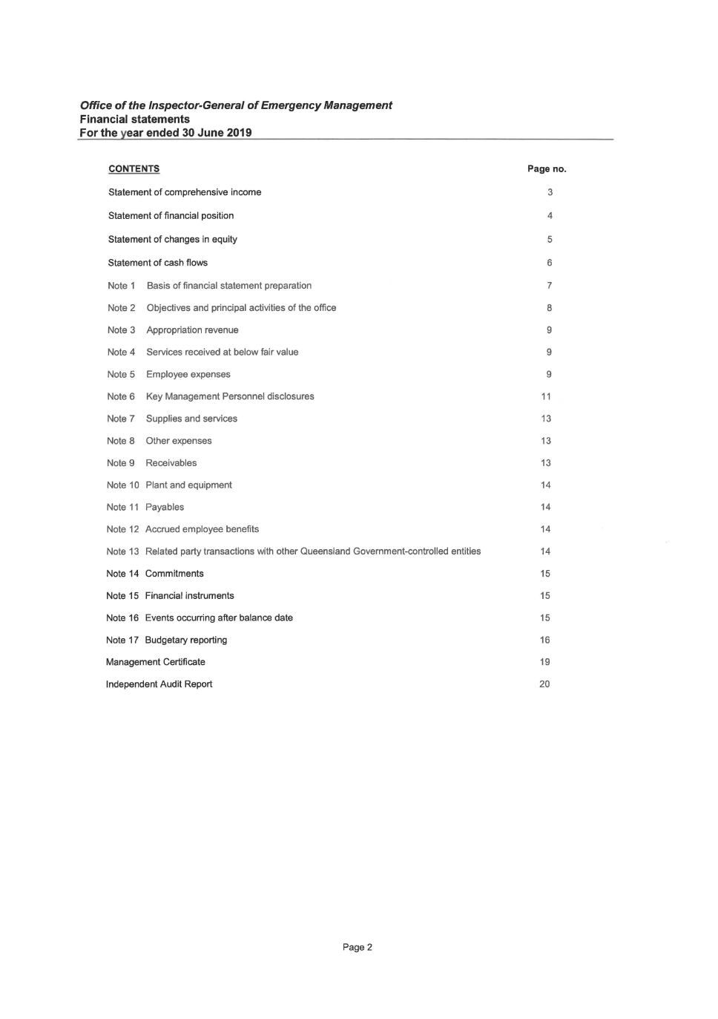

Office of the Inspector-General of Emergency Management

Financial Statements

For the year ended 30 June 2019

***Office of the Inspector-General of Emergency Management***

**Financial statements**

**For the year ended 30 June 2019**

**CONTENTS**

Statement of comprehensive income

Statement of financial position

Statement of changes in equity

Statement of cash flows

Note 1 Basis of financial statement preparation

Note 2 Objectives and principal activities of the office

Note 3 Appropriation revenue

Note 4 Services received at below fair value

Note 5 Employee expenses

Note 6 Key Management Personnel disclosures

Note 7 Supplies and services

Note 8 Other expenses

Note 9 Receivables

Note 1 0 Plant and equipment

Note 11 Payables

Note 12 Accrued employee benefits

Note 13 Related party transactions with other Queensland Government-controlled entities

Note 14 Commitments

Note 15 Financial instruments

Note 16 Events occurring after balance date

Note 17 Budgetary reporting

Management Certificate

Independent Audit Report

Page 2

**Page no.**

3

4

5

6

7

8

9

9

9

11

13

13

13

14

14

14

14

15

15

15

16

19

20

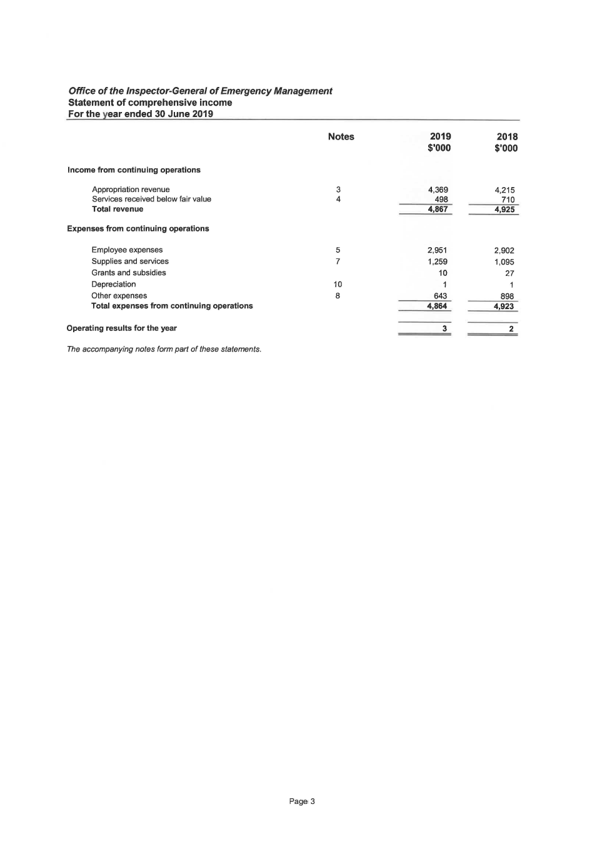

*Office of the Inspector-General of Emergency Management*

Statement of comprehensive income

For the year ended 30 June 2019

Notes

Income from continuing operations

Appropriation revenue

Services received below fair value

Total revenue

Expenses from continuing operations

Employee expenses

Supplies and services

Grants and subsidies

Depreciation

Other expenses

Total expenses from continuing operations

Operating results for the year

*The accompanying notes form part of these statements.*

Page 3

3

4

5

7

10

8

2019

$'000

4,369

498

4,867

2,951

1,259

10

1

643

4,864

3

2018

$'000

4,215

710

4,925

2,902

1,095

27

1

898

4,923

2

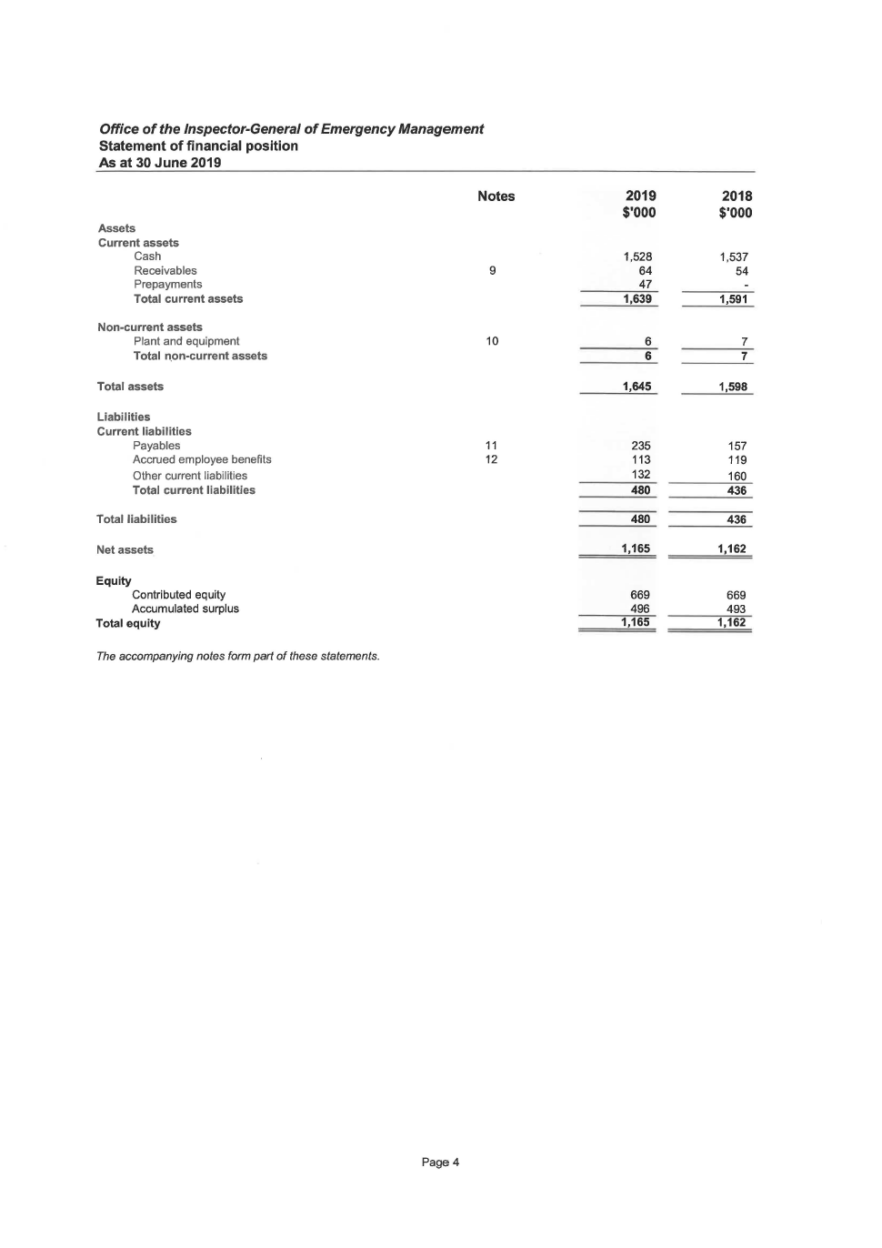

*Office of the Inspector-General of Emergency Management*

Statement of financial position

As at 30 June 2019

Notes

Assets

Current assets

Cash

Receivables

Prepayments

Total current assets

Non-current assets

Plant and equipment

Total n.on-current assets

Total assets

Liabilities

Current liabilities

Payables

Accrued employee benefits

Other current liabilities

Total current liabilities

Total liabilities

Net assets

Equity

Contributed equity

Accumulated surplus

Total equity

*The accompanying notes form part of these statements.*

9

10

11

12

Page4

2019 2018

$'000 $'000

1,528 1,537

64 54

47

1,639 1,591

6 7

6 7

1,645 1,598

235 157

113 119

132 160

480 436

480 436

1,165 1,162

669 669

496 493

1,165 1,162

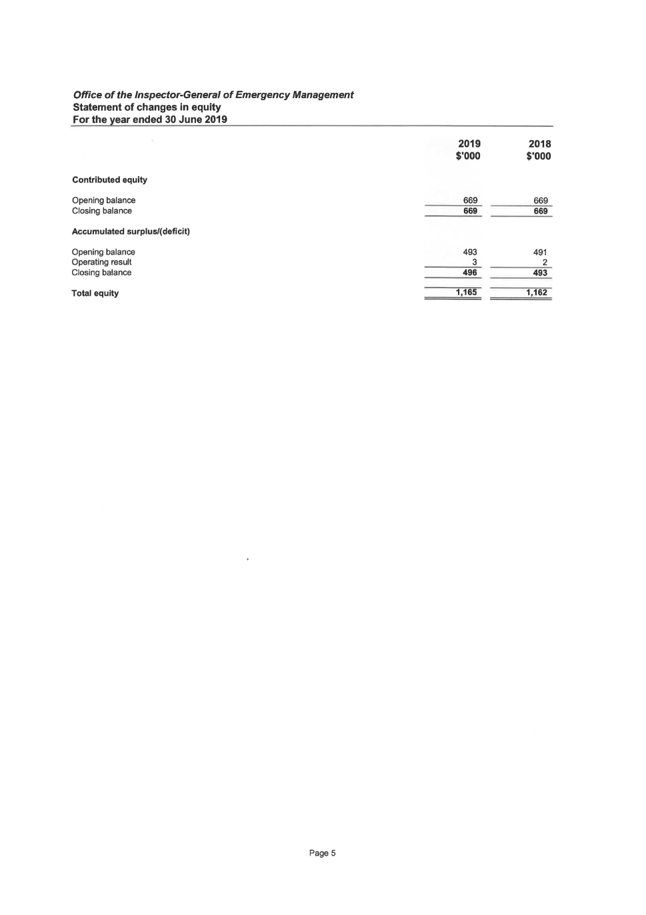

*Office of the Inspector-General of Emergency Management*

Statement of changes in equity

For the year ended 30 June 2019

Contributed equity

Opening balance

Closing balance

Accumulated surplus/( deficit)

Opening balance

Operating result

Closing balance

Total equity

Page 5

2019

$'000

669

669

493

3

496

1,165

2018

$'000

669

669

491

2

493

1,162

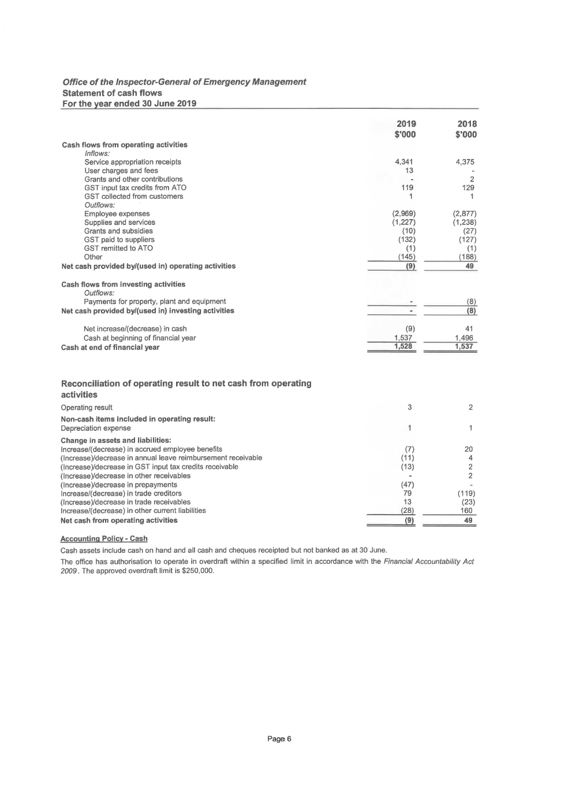

*Office of the Inspector-General of Emergency Management*

Statement of cash flows

For the year ended 30 June 2019

Cash flows from operating activities

*Inflows:*

Service appropriation receipts

User charges and fees

Grants and other contributions

GST input tax credits from ATO

GST collected from customers

*Outflows:*

Employee expenses

Supplies and services

Grants and subsidies

GST paid to suppliers

GST remitted to ATO

Other

Net cash provided by/(used in) operating activities

Cash flows from investing activities

*Outflows:*

Payments for property, plant and equipment

Net cash provided by/(used in) investing activities

Net increase/( decrease) in cash

Cash at beginning of financial year

Cash at end of financial year

Reconciliation of operating result to net cash from operating

activities

Operating result

Non-cash items included in operating result:

Depreciation expense

Change in assets and liabilities:

lncrease/(decrease) in accrued employee benefits

(lncrease)/decrease in annual leave reimbursement receivable

(lncrease)/decrease in GST input tax credits receivable

(lncrease)/decrease in other receivables

(lncrease)/decrease in prepayments

lncrease/(decrease) in trade creditors

(lncrease)/decrease in trade receivables

Increase/( decrease) in other current liabilities

Net cash from operating activities

Accounting Policy- Cash

Cash assets include cash on hand and all cash and cheques receipted but not banked as at 30 June.

2019 2018

$'000 $'000

4,341 4,375

13

2

119 129

1 1

(2,969) (2,877)

(1 ,227) (1 ,238)

(10) (27)

(132) (127)

(1) (1)

(145) {188)

(9) 49

~8}

{8}

(9) 41

1,537 1,496

1,528 1,537

3 2

(7) 20

(11) 4

(13) 2

2

(47)

79 (119)

13 (23}

(28) 160

(9) 49

The office has authorisation to operate in overdraft within a specified limit in accordance with the *Financial Accountability Act*

*2009.* The approved overdraft limit is $250,000.

Page

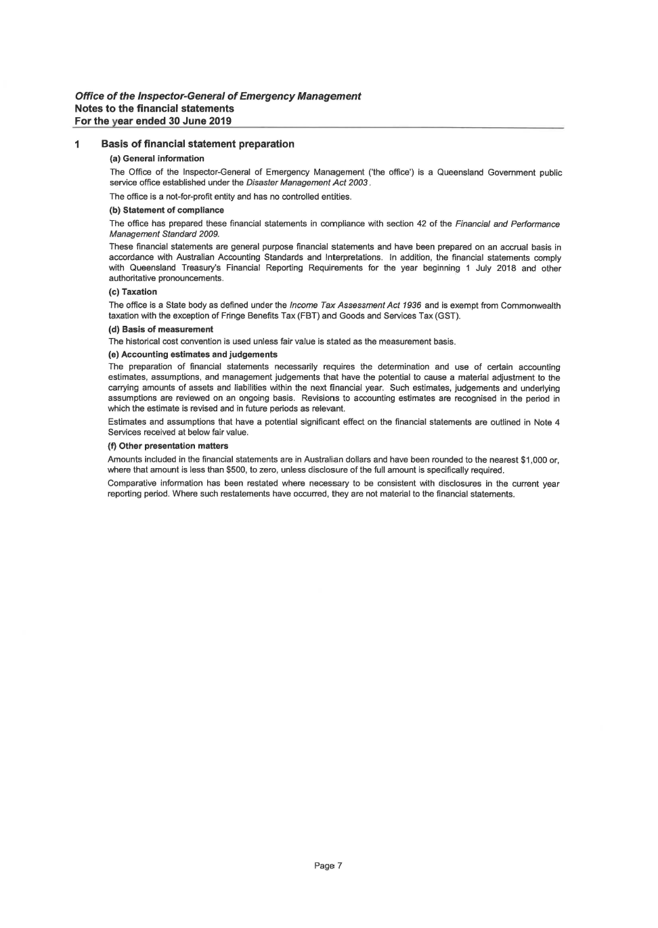

***Office of the Inspector-General of Emergency Management***

**Notes to the financial statements**

**For the year ended 30 June 2019**

**1 Basis of financial statement preparation**

(a) **General information**

The Office of the Inspector-General of Emergency Management ('the office') is a Queensland Government public

service office established under the *Disaster Management Act 2003* .

The office is a not-for-profit entity and has no controlled entities.

**(b) Statement of compliance**

The office has prepared these financial statements in compliance with section 42 of the *Financial and Performance*

*Management Standard 2009.*

These financial statements are general purpose financial statements and have been prepared on an accrual basis in

accordance with Australian Accounting Standards and Interpretations. In addition, the financial statements comply

with Queensland Treasury's Financial Reporting Requirements for the year beginning 1 July 2018 and other

authoritative pronouncements.

(c) **Taxation**

The office is a State body as defined under the *Income Tax Assessment Act 1936* and is exempt from Commonwealth

taxation with the exception of Fringe Benefits Tax (FBT) and Goods and Services Tax (GST).

**(d) Basis of measurement**

The historical cost convention is used unless fair value is stated as the measurement basis.

**(e) Accounting estimates and judgements**

The preparation of financial statements necessarily requires the determination and use of certain accounting

estimates, assumptions, and management judgements that have the potential to cause a material adjustment to the

carrying amounts of assets and liabilities within the next financial year. Such estimates, judgements and underlying

assumptions are reviewed on an ongoing basis. Revisions to accounting estimates are recognised in the period in

which the estimate is revised and in future periods as relevant.

Estimates and assumptions that have a potential significant effect on the financial statements are outlined in Note 4

Services received at below fair value.

**(f) Other presentation matters**

Amounts included in the financial statements are in Australian dollars and have been rounded to the nearest $1,000 or,

where that amount is less than $500, to zero, unless disclosure of the full amount is specifically required.

Comparative information has been restated where necessary to be consistent with disclosures in the current year

reporting period. Where such restatements have occurred, they are not material to the financial statements.

Page

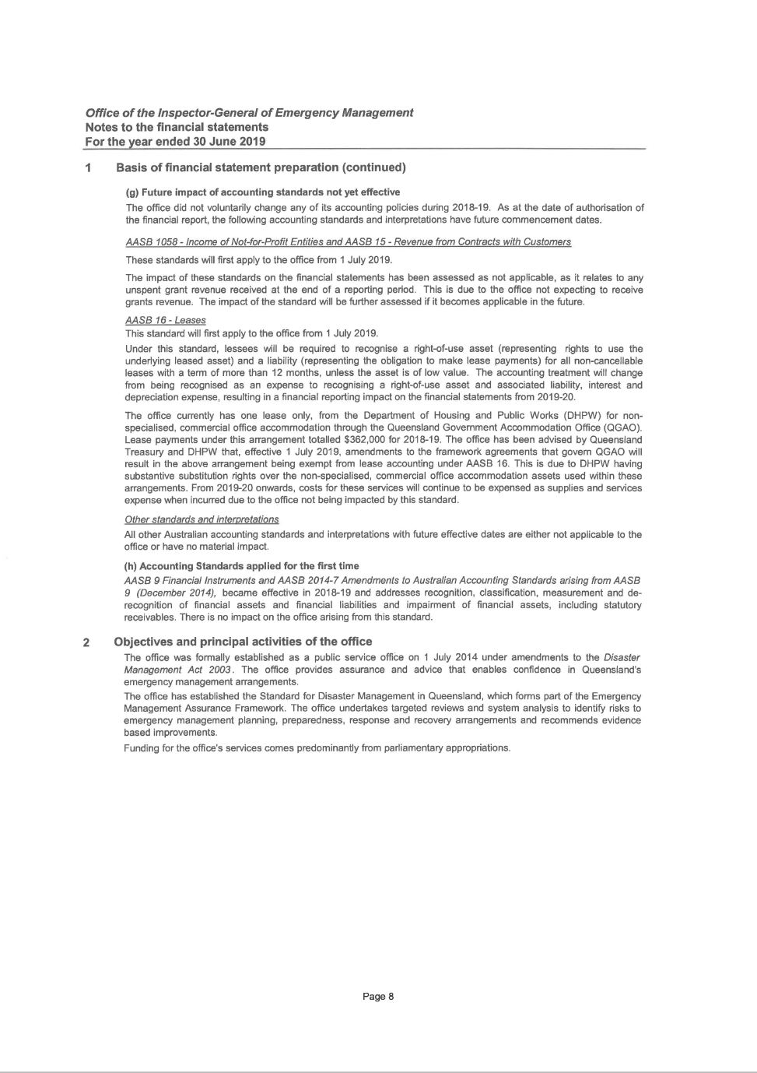

***Office of the Inspector-General of Emergency Management***

**Notes to the financial statements**

**For the year ended 30 June 2019**

**1 Basis of financial statement preparation (continued)**

**(g) Future impact of accounting standards not yet effective**

The office did not voluntarily change any of its accounting policies during 2018-19. As at the date of authorisation of

the financial report, the following accounting standards and interpretations have future commencement dates.

*AASB 1058 -Income of Not-for-Profit Entities and AASB 15- Revenue from Contracts with Customers*

These standards will first apply to the office from 1 July 2019.

The impact of these standards on the financial statements has been assessed as not applicable, as it relates to any

unspent grant revenue received at the end of a reporting period. This is due to the office not expecting to receive

grants revenue. The impact of the standard will be further assessed if it becomes applicable in the future.

*AASB 16-* Leases

This standard will first apply to the office from 1 July 2019.

Under this standard, lessees will be required to recognise a right-of-use asset (representing rights to use the

underlying leased asset) and a liability (representing the obligation to make lease payments) for all non-cancellable

leases with a term of more than 12 months, unless the asset is of low value. The accounting treatment will change

from being recognised as an expense to recognising a right-of-use asset and associated liability, interest and

depreciation expense, resulting in a financial reporting impact on the financial statements from 2019-20.

The office currently has one lease only, from the Department of Housing and Public Works (DHPW) for nonspecialised,

commercial office accommodation through the Queensland Government Accommodation Office (QGAO).

Lease payments under this arrangement totalled $362,000 for 2018-19. The office has been advised by Queensland

Treasury and DHPW that, effective 1 July 2019, amendments to the framework agreements that govern QGAO will

result in the above arrangement being exempt from lease accounting under AASB 16. This is due to DHPW having

substantive substitution rights over the non-specialised, commercial office accommodation assets used within these

arrangements. From 2019-20 onwards, costs for these services will continue to be expensed as supplies and services

expense when incurred due to the office not being impacted by this standard.

*Other standards and interpretations*

All other Australian accounting standards and interpretations with future effective dates are either not applicable to the

office or have no material impact.

**(h) Accounting Standards applied for the first time**

*AASB 9 Financial Instruments and AASB 2014-7 Amendments to Australian Accounting Standards arising from AASB*

*9 (December 2014),* became effective in 2018-19 and addresses recognition, classification, measurement and derecognition

of financial assets and financial liabilities and impairment of financial assets, including statutory

receivables. There is no impact on the office arising from this standard.

**2 Objectives and principal activities of the office**

The office was formally established as a public service offiee on 1 July 2014 under amendments to the *Disaster*

*Management Act 2003.* The office provides assurance and advice that enables confidence in Queensland's

emergency management arrangements.

The office has established the Standard for Disaster Management in Queensland, which forms part of the Emergency

Management Assurance Framework. The office undertakes targeted reviews and system analysis to identify risks to

emergency management planning, preparedness, response and recovery arrangements and recommends evidence

based improvements.

Funding for the office's services comes predominantly from parliamentary appropriations.

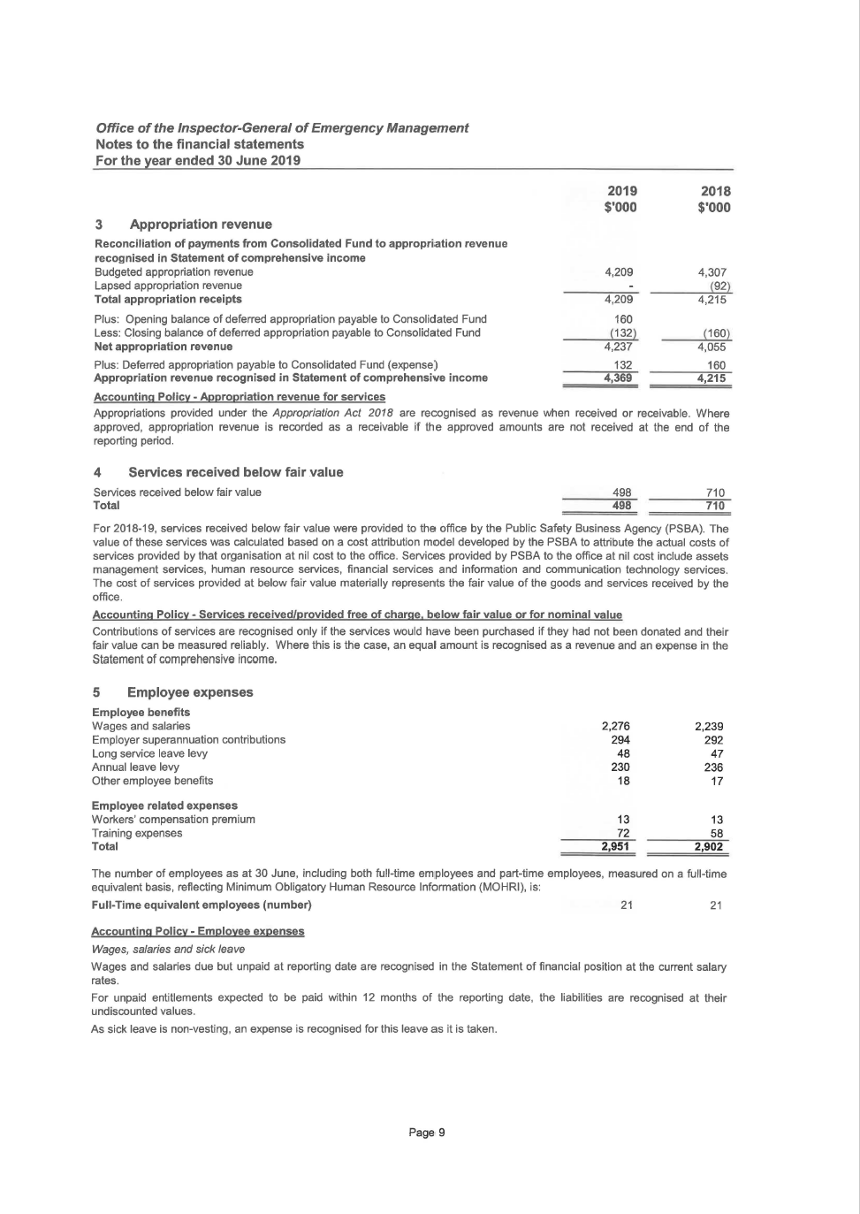

*Office of the Inspector-General of Emergency Management*

Notes to the financial statements

For the year ended 30 June 2019

3 Appropriation revenue

Reconciliation of payments from Consolidated Fund to appropriation revenue

recognised in Statement of comprehensive income

Budgeted appropriation revenue

Lapsed appropriation revenue

Total appropriation receipts

Plus: Opening balance of deferred appropriation payable to Consolidated Fund

Less: Closing balance of deferred appropriation payable to Consolidated Fund

Net appropriation revenue

Plus: Deferred appropriation payable to Consolidated Fund (expense)

Appropriation revenue recognised in Statement of comprehensive income

Accounting Policy- Appropriation revenue for services

2019

$'0004,209

4,209

160

(132)

4,237132

4,369

2018$'000

4,307{92}

4,215

{160~

4,055

160

4,215

Appropriations provided under the *Appropriation Act 2018* are recognised as revenue when received or receivable. Where

approved, appropriation revenue is recorded as a receivable if the approved amounts are not received at the end of the

reporting period.

4 Services received below fair value

Services received below fair value 498 710

Total 498 710

For 2018-19, services received below fair value were provided to the office by the Public Safety Business Agency (PSBA). The

value of these services was calculated based on a cost attribution model developed by the PSBA to attribute the actual costs of

services provided by that organisation at nil cost to the office. Services provided by PSBA to the office at nil cost include assets

management services, human resource services, financial services and information and communication technology services.

The cost of services provided at below fair value materially represents the fair value of the goods and services received by the

office.

Accounting Policy- Services received/provided free of charge. below fair value or for nominal value

Contributions of services are recognised only if the services would have been purchased if they had not been donated and their

fair value can be measured reliably. Where this is the case, an equal amount is recognised as a revenue and an expense in the

Statement of comprehensive income.

5 Employee expenses

Employee benefits

Wages and salaries

Employer superannuation contributions

Long service leave levy

Annual leave levy

Other employee benefits

Employee related expenses

Workers' compensation premium

Training expenses

Total

2,276

294

48

230

18

13

722,951

2,239

292

47

236

17

13

58

2,902

The number of employees as at 30 June, including both full-time employees and part-time employees, measured on a full-time

equivalent basis, reflecting Minimum Obligatory Human Resource Information (MOHRI), is:

Full-Time equivalent employees (number) 21 21

Accounting Policy- Employee expenses

*Wages,* sa/aries *and sick leave*

Wages and salaries due but unpaid at reporting date are recognised in the Statement of financial position at the current salary

rates.

For unpaid entitlements expected to be paid within 12 months of the reporting date, the liabilities are recognised at their

undiscounted values.

As sick leave is non-vesting, an expense is recognised for this leave as it is taken.

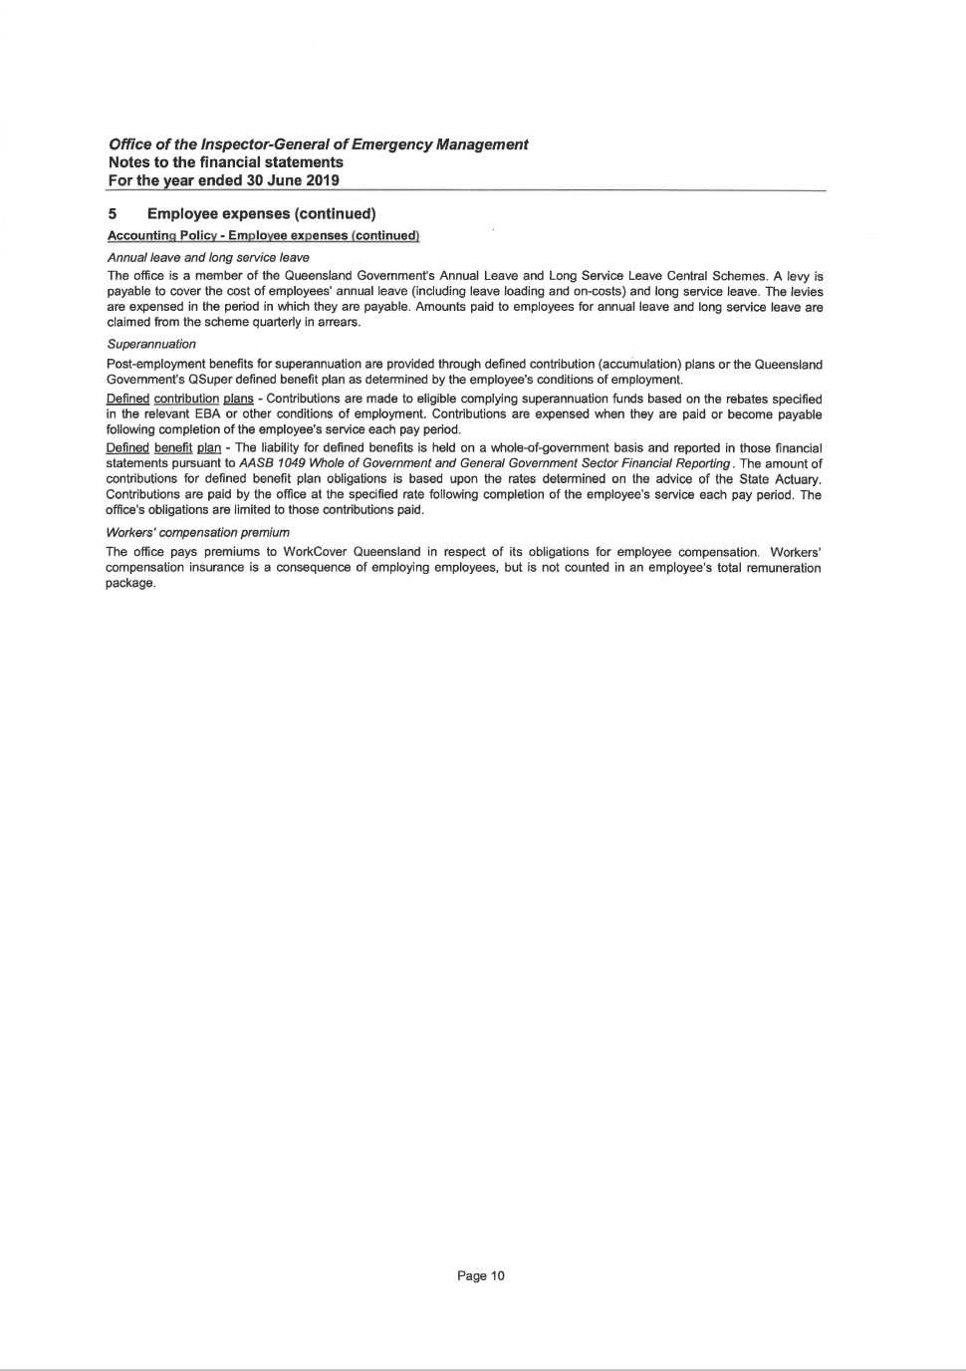

***Office of the Inspector-General of Emergency Management***

**Notes to the financial statements**

**For the year ended 30 June 2019**

**5 Employee expenses (continued)**

**Accounting Policy · Employee expenses (continued)**

*Annual/eave and long service leave*

The office is a member of the Queensland Government's Annual Leave and Long Service Leave Central Schemes. A levy is

payable to cover the cost of employees' annual leave (including leave loading and on-costs) and long service leave. The levies

are expensed in the period in which they are payable. Amounts paid to employees for annual leave and long service leave are

claimed from the scheme quarterly in arrears.

*Superannuation*

Post-employment benefits for superannuation are provided through defined contribution (accumulation) plans or the Queensland

Government's QSuper defined benefit plan as determined by the employee's conditions of employment.

Defined contribution plans - Contributions are made to eligible complying superannuation funds based on the rebates specified

in the relevant EBA or other conditions of employment. Contributions are expensed when they are paid or become payable

following completion of the employee's service each pay period.

Defined benefit .P@n- The liability for defined benefits is held on a whole-of-government basis and reported in those financial

statements pursuant to AASB *1049 Whole of Government and General Government Sector Financial Reporting.* The amount of

contributions for defined benefit plan obligations is based upon the rates determined on the advice of the State Actuary.

Contributions are paid by the office at the specified rate following completion of the employee's service each pay period. The

office's obligations are limited to those contributions paid.

*Workers' compensation premium*

The office pays premiums to WorkCover Queensland in respect of its obligations for employee compensation. Workers'

compensation insurance is a consequence of employing employees, but is not counted in an employee's total remuneration

package.

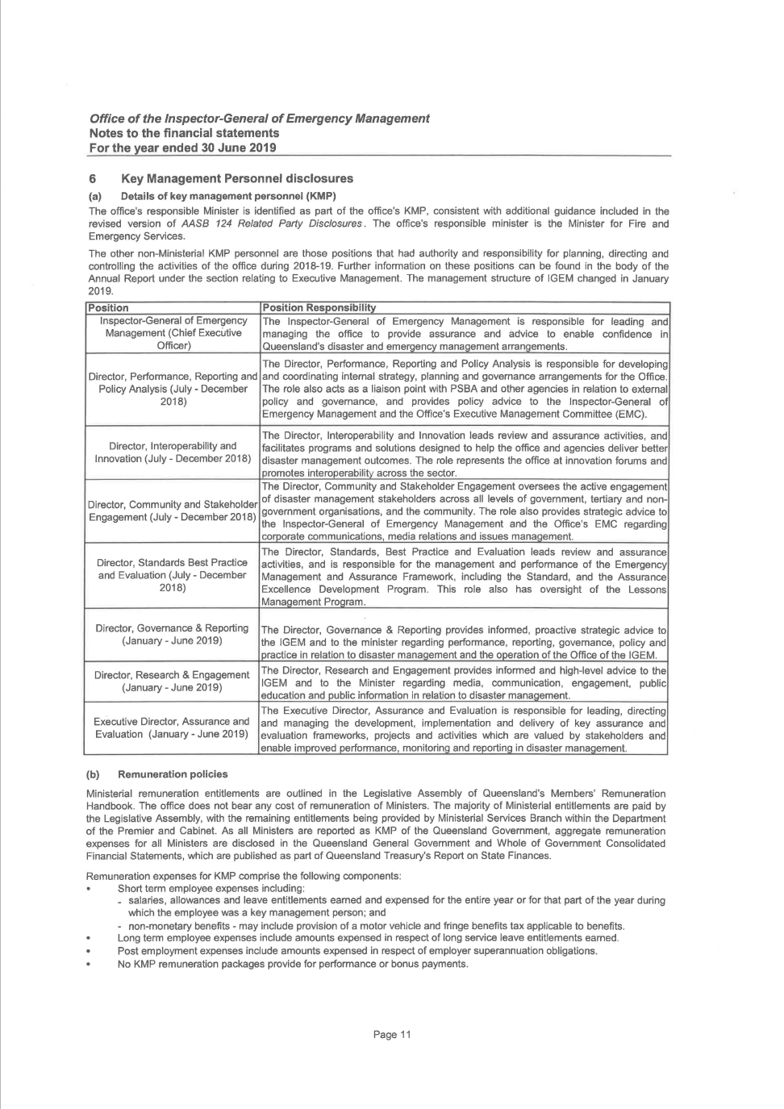

***Office of the Inspector-General of Emergency Management***

**Notes to the financial statements**

**For the year ended 30 June 2019**

**6 Key Management Personnel disclosures**

**(a) Details of key management personnel (KMP)**

The office's responsible Minister is identified as part of the office's KMP, consistent with additional guidance included in the

revised version of *AASB 124 Related Party Disclosures.* The office's responsible minister is the Minister for Fire and

Emergency Services.

The other non-Ministerial KMP personnel are those positions that had authority and responsibility for planning, directing and

controlling the activities of the office during 2018-19. Further information on these positions can be found in the body of the

Annual Report under the section relating to Executive Management. The management structure of IGEM changed in January

2019.

**Position Position Responsibility**

Inspector-General of Emergency The Inspector-General of Emergency Management is responsible for leading and

Management (Chief Executive managing the office to provide assurance and advice to enable confidence in

Officer) Queensland's disaster and emergency management arrangements.

The Director, Performance, Reporting and Policy Analysis is responsible for developing

Director, Performance, Reporting and and coordinating internal strategy, planning and governance arrangements for the Office.

Policy Analysis (July- December The role also acts as a liaison point with PSBA and other agencies in relation to external

2018) policy and governance, and provides policy advice to the Inspector-General of

Emergency Management and the Office's Executive Management Committee (EMC).

The Director, lnteroperability and Innovation leads review and assurance activities, and

Director, lnteroperability and facilitates programs and solutions designed to help the office and agencies deliver better

Innovation (July- December 2018) disaster management outcomes. The role represents the office at innovation forums and

promotes interoperability across the sector.

The Director, Community and Stakeholder Engagement oversees the active engagement

Director, Community and Stakeholder of disaster management stakeholders across all levels of government, tertiary and non-

Engagement (July- December 2018) government organisations, and the community. The role also provides strategic advice to

the Inspector-General of Emergency Management and the Office's EMC regarding

corporate communications, media relations and issues management.

The Director, Standards, Best Practice and Evaluation leads review and assurance

Director, Standards Best Practice activities, and is responsible for the management and performance of the Emergency

and Evaluation (July- December Management and Assurance Framework, including the Standard, and the Assurance

2018) Excellence Development Program. This role also has oversight of the Lessons

Management Program.

Director, Governance & Reporting The Director, Governance & Reporting provides informed, proactive strategic advice to

(January- June 2019) the IGEM and to the minister regarding performance, reporting, governance, policy and

practice in relation to disaster management and the operation of the Office of the IGEM.

Director, Research & Engagement The Director, Research and Engagement provides informed and high-level advice to the

(January- June 2019) I GEM and to the Minister regarding media, communication, engagement, public

education and public information in relation to disaster management.

The Executive Director, Assurance and Evaluation is responsible for leading, directing

Executive Director, Assurance and and managing the development, implementation and delivery of key assurance and

Evaluation (January- June 2019) evaluation frameworks, projects and activities which are valued by stakeholders and

enable improved performance, monitoring and reporting in disaster management.

**(b) Remuneration policies**

Ministerial remuneration entitlements are outlined in the Legislative Assembly of Queensland's Members' Remuneration

Handbook. The office does not bear any cost of remuneration of Ministers. The majority of Ministerial entitlements are paid by

the Legislative Assembly, with the remaining entitlements being provided by Ministerial Services Branch within the Department

of the Premier and Cabinet. As all Ministers are reported as KMP of the Queensland Government, aggregate remuneration

expenses for all Ministers are disclosed in the Queensland General Government and Whole of Government Consolidated

Financial Statements, which are published as part of Queensland Treasury's Report on State Finances.

Remuneration expenses for KMP comprise the following components:

Short term employee expenses including:

\_ salaries, allowances and leave entitlements earned and expensed for the entire year or for that part of the year during

which the employee was a key management person; and

- non-monetary benefits - may include provision of a motor vehicle and fringe benefits tax applicable to benefits.

Long term employee expenses include amounts expensed in respect of long service leave entitlements earned.

Post employment expenses include amounts expensed in respect of employer superannuation obligations.

No KMP remuneration packages provide for performance or bonus payments.

Page 11

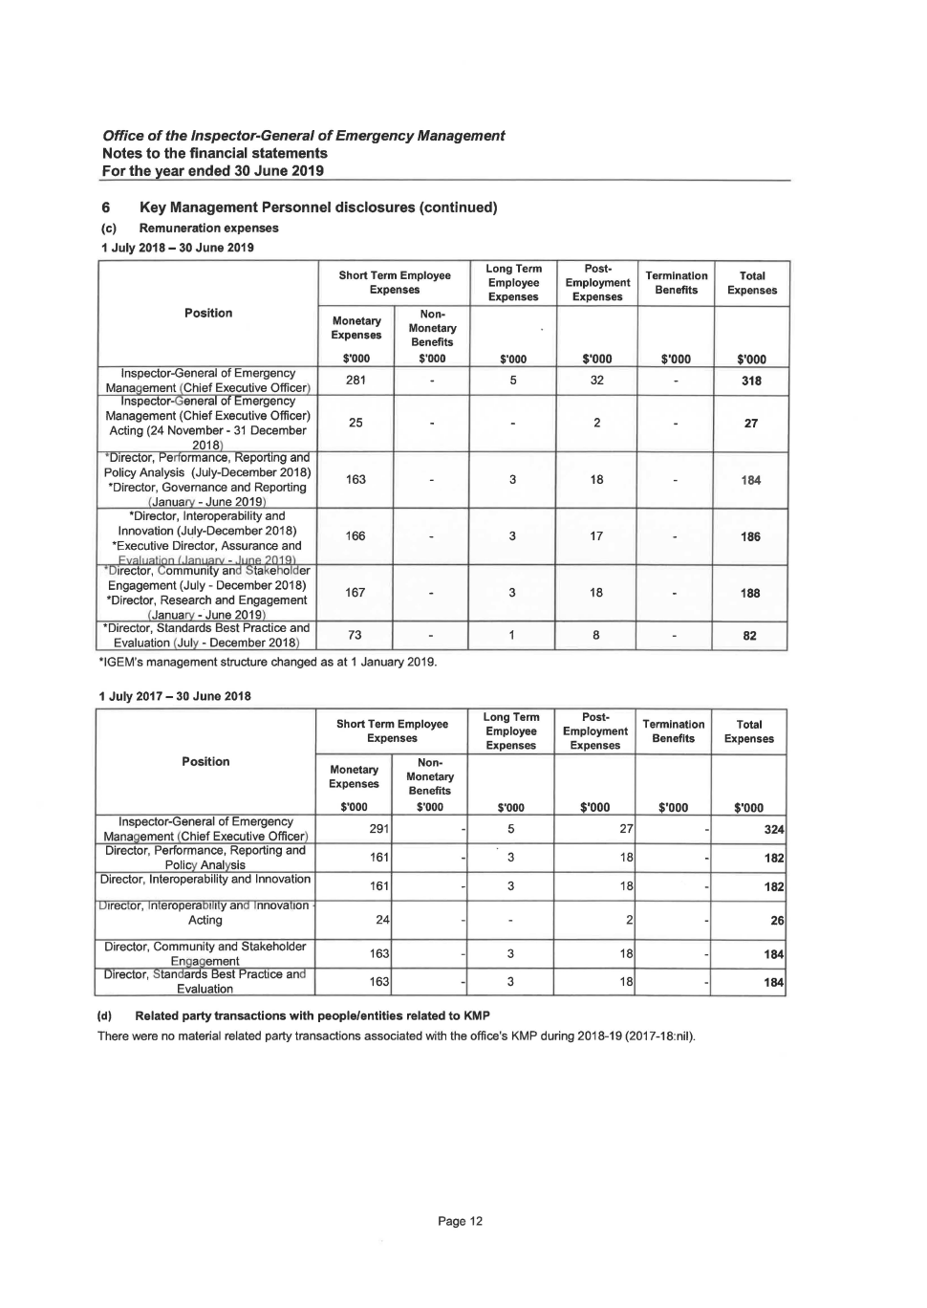

*Office of the Inspector-General of Emergency Management*

Notes to the financial statements

For the year ended 30 June 2019

6 Key Management Personnel disclosures (continued)

(c) Remuneration expenses

1 July 2018-30 June 2019

Short Term Employee

Long Term

ExpensesEmployee

ExpensesPosition

MonetaryNon-MonetaryExpenses

Benefits

$'000 $'000 $'000

Inspector-General of Emergency

281 - 5

Management (Chief Executive Officer)

Inspector-General of Emergency

Management {Chief Executive Officer)

25 - - Acting (24 November- 31 December

2018)

\*Director, Performance, Reporting and Policy Analysis (July-December 2018)163 - 3

\*Director, Governance and Reporting(January - June 2019)

\*Director, lnteroperability andInnovation (July-December 2018) 166 - 3

\*Executive Director, Assurance andI=· r<:>l: ·~ti"ln *(* Januarv - June ?n1 q''U1rector, t.:ommumty and !:>takeholder

Engagement (July- December 2018)

167 - 3

\*Director, Research and Engagement (January - June 2019)

\*Director, Standards Best Practice and 73 - 1

Evaluation (July - December 2018) \*IGEM's management structure changed as at 1 January 2019.

1 July 2017-30 June 2018

Short Term Employee

Long Term

Expenses

EmployeeExpenses

Position

MonetaryNon-

Monetary

ExpensesBenefits

$'000 $'000 $'000

Inspector-General of Emergency

291 - 5

Management (Chief Executive Officer) Director, Performance, Reporting and

161 - 3

Policy Analysis Director, lnteroperability and Innovation161 – 3 UJrector, JmeroperaOJmy ana mnovauon

Acting 24 - -

Director, Community and Stakeholder 163 - 3

Engagement

Director, Standards Best Practice and163 - 3

Evaluation

(d) Related party transactions with people/entities related to KMP

Post- Employment Termination

Benefits Expenses

$'000 $'000

32 -2 -18 -17 -

18 -8 -

Post- TerminationEmploymentBenefitsExpenses$'000 $'000

27 -18 -18 -2 -

18 -18 -

There were no material related party transactions associated with the office's KMP during 2018-19 (2017-18:nil).

Page 12

Total

Expenses$'000

31827

184186

188

82TotalExpenses

$'000

324182

18226

184

184

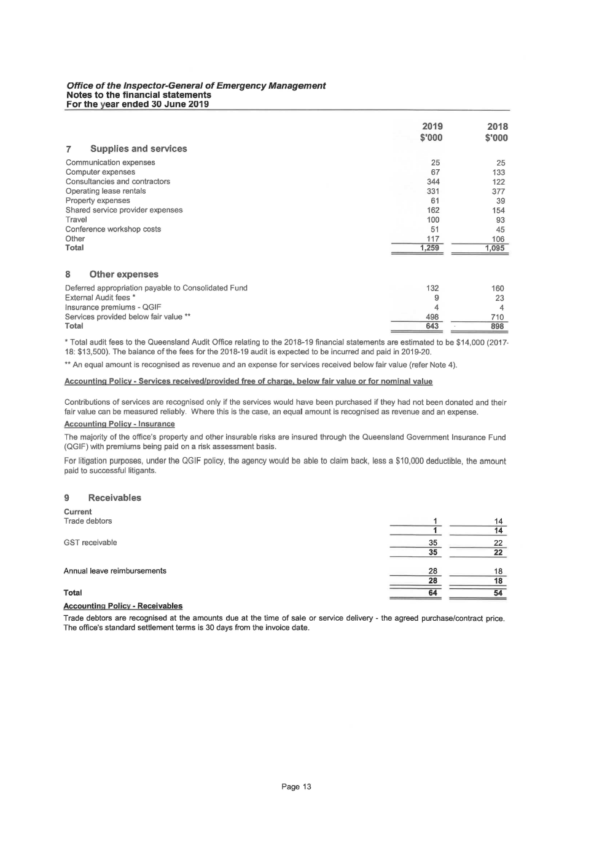

*Office of the Inspector-General of Emergency Management*

Notes to the financial statements

For the year ended 30 June 2019

7 Supplies and services

Communication expenses

Computer expenses

Consultancies and contractors

Operating lease rentals

Property expenses

Shared service provider expenses

Travel

Conference workshop costs

Other

Total

8 Otherexpenses

Deferred appropriation payable to Consolidated Fund

External Audit fees \*

Insurance premiums - QGIF

Services provided below fair value \*\*

Total

2019

$'000

25

67

344331

61

162

100

51

1171,259132

9

4

498643

2018

$'000

25

133

122377

39

154

93

45

106

1,095

16023

4

710

898

\*Total audit fees to the Queensland Audit Office relating to the 2018-19 financial statements are estimated to be $14,000 (2017-

18: $13,500}. The balance of the fees for the 2018-19 audit is expected to be incurred and paid in 2019-20.

\*\*An equal amount is recognised as revenue and an expense for services received below fair value (refer Note 4).

Accounting Policy- Services received/provided free of charge. below fair value or for nominal value

Contributions of services are recognised only if the services would have been purchased if they had not been donated and their

fair value can be measured reliably. Where this is the case, an equal amount is recognised as revenue and an expense.

Accounting Policy- Insurance

The majority of the office's property and other insurable risks are insured through the Queensland Government Insurance Fund

(QGIF} with premiums being paid on a risk assessment basis.

For litigation purposes, under the QGIF policy, the agency would be able to claim back, less a $10,000 deductible, the amount

paid to successful litigants.

9 Receivables

Current

Trade debtors 14

14

GST receivable 35 22

35 22

Annual leave reimbursements 28 18

28 18

Total 64 54

Accounting Policy - Receivables

Trade debtors are recognised at the amounts due at the time of sale or service delivery- the agreed purchase/contract price.

The office's standard settlement terms is 30 days from the invoice date.

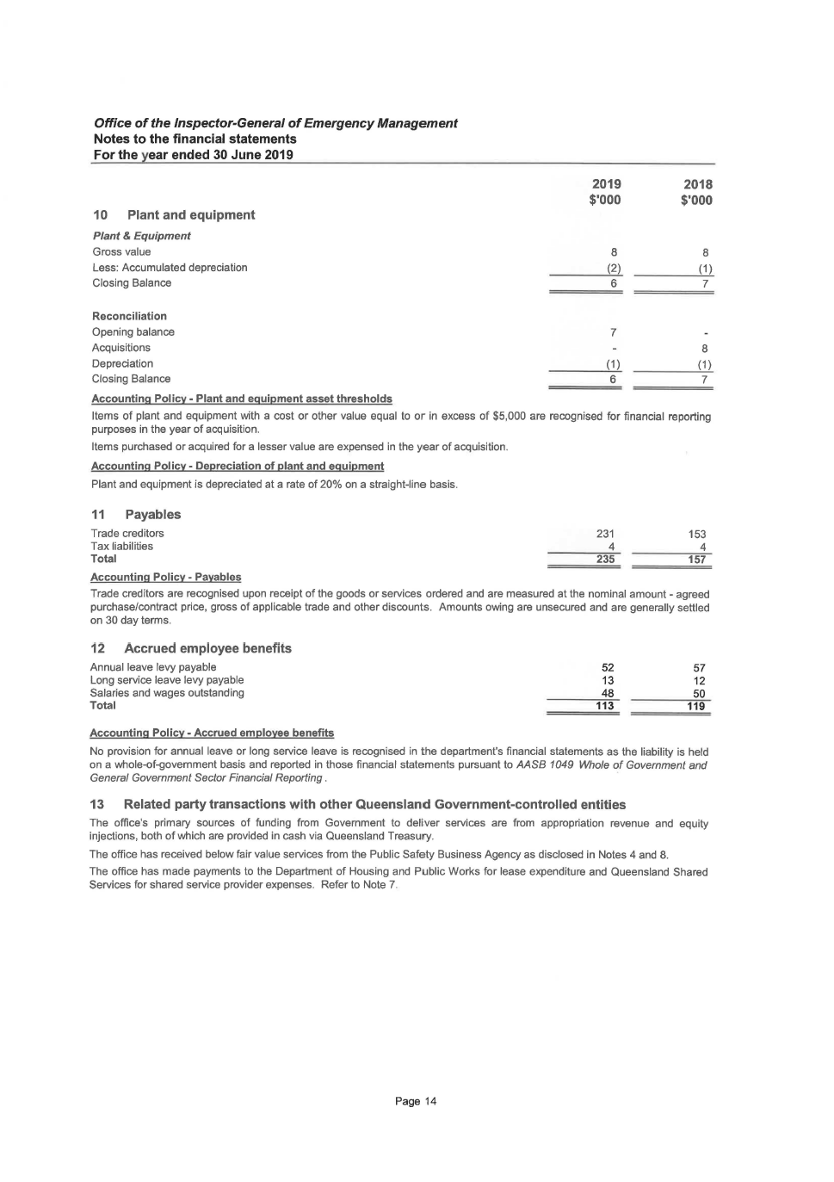

*Office of the Inspector-General of Emergency Management*

Notes to the financial statements

For the year ended 30 June 2019

10 Plant and equipment

*Plant* & *Equipment*

Gross value

Less: Accumulated depreciation

Closing Balance

Reconciliation

Opening balance

Acquisitions

Depreciation

Closing Balance

Accounting Policy- Plant and equipment asset thresholds

2019

$'000

8

(2)6

7

(1)

6

2018

$'0008

(1)

78

(1)

7

Items of plant and equipment with a cost or other value equal to or in excess of $5,000 are recognised for financial reporting

purposes in the year of acquisition.

Items purchased or acquired for a lesser value are expensed in the year of acquisition.

Accounting Policy- Depreciation of plant and equipment

Plant and equipment is depreciated at a rate of 20% on a straight-line basis.

11 Payables

Trade creditors

Tax liabilities

Total

Accounting Policy - Payables

231

4

235

153

4

157

Trade creditors are recognised upon receipt of the goods or services ordered and are measured at the nominal amount - agreed

purchase/contract price, gross of applicable trade and other discounts. Amounts owing are unsecured and are generally settled

on 30 day terms.

12 Accrued employee benefits

Annual leave levy payable

Long service leave levy payable

Salaries and wages outstanding

Total

Accounting Policy- Accrued employee benefits

52

13

48

113

57

12

50

119

No provision for annual leave or long service leave is recognised in the department's financial statements as the liability is held

on a whole-of-government basis and reported in those financial statements pursuant to AASB *1049 Whole of Government and*

*General Government Sector Financial Reporting* .

13 Related party transactions with other Queensland Government-controlled entities

The office's primary sources of funding from Government to deliver services are from appropriation revenue and equity

injections, both of which are provided in cash via Queensland Treasury.

The office has received below fair value services from the Public Safety Business Agency as disclosed in Notes 4 and 8.

The office has made payments to the Department of Housing and Public Works for lease expenditure and Queensland Shared

Services for shared service provider expenses. Refer to Note 7.

Page

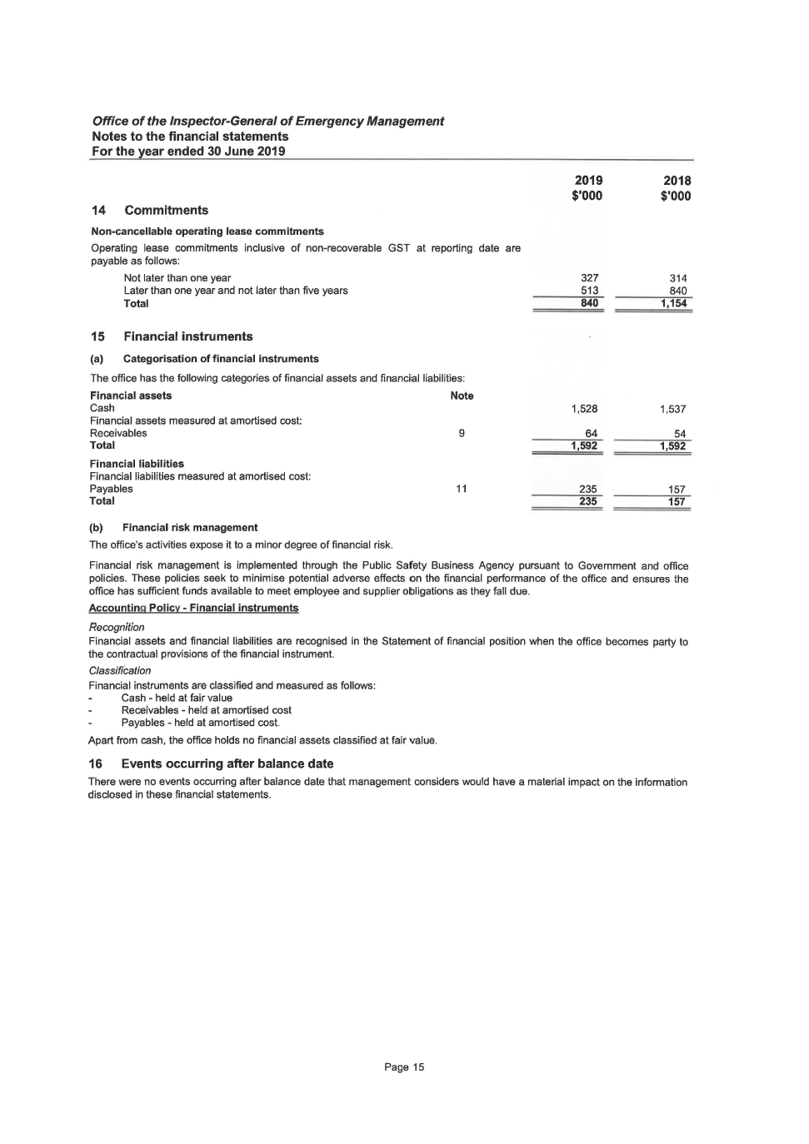

*Office of the Inspector-Genera/ of Emergency Management*

Notes to the financial statements

For the year ended 30 June 2019

14 Commitments

Non-cancellable operating lease commitments

Operating lease commitments inclusive of non-recoverable GST at reporting date are

payable as follows:

Not later than one year

Later than one year and not later than five years

Total

15 Financial instruments

(a) Categorisation of financial instruments

The office has the following categories of financial assets and financial liabilities:

Financial assets Note

Cash

Financial assets measured at amortised cost:

Receivables

Total

Financial liabilities

Financial liabilities measured at amortised cost:

Payables

Total

(b) Financial risk management

The office's activities expose it to a minor degree of financial risk.

9

11

2019

s·ooo

327

513

840

1,528

64

1,592

235

2352018

s·ooo

314

840

1,154

1,537

54

1,592

157

157

Financial risk management is implemented through the Public Safety Business Agency pursuant to Government and office

policies. These policies seek to minimise potential adverse effects on the financial performance of the office and ensures the

office has sufficient funds available to meet employee and supplier obligations as they fall due.

Accounting Policy - Financial instruments

*Recognition*

Financial assets and financial liabilities are recognised in the Statement of financial position when the office becomes party to

the contractual provisions of the financial instrument.

*Classification*

Financial instruments are classified and measured as follows:

Cash - held at fair value

Receivables - held at amortised cost

Payables - held at amortised cost.

Apart from cash, the office holds no financial assets classified at fair value.

16 Events occurring after balance date

There were no events occurring after balance date that management considers would have a material impact on the information

disclosed in these financial statements.

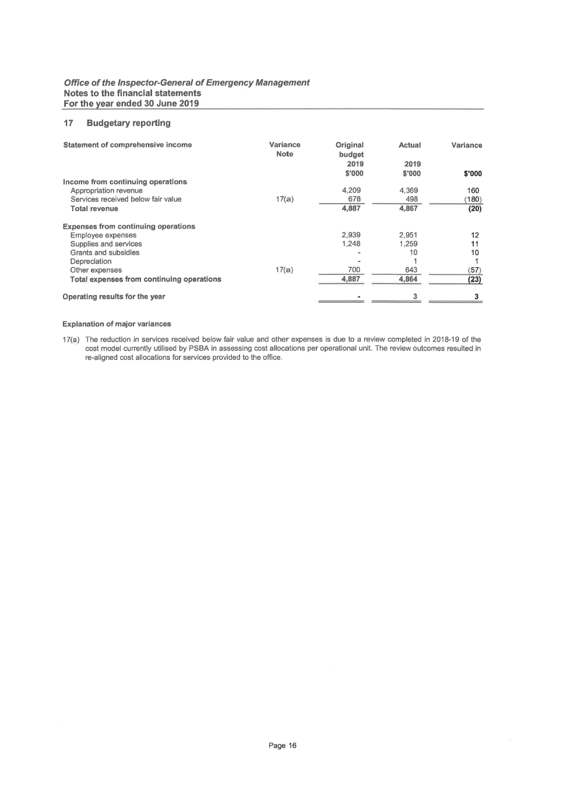

*Office of the Inspector-Genera/ of Emergency Management*

Notes to the financial statements

For the year ended 30 June 2019

14 Commitments

Non-cancellable operating lease commitments

Operating lease commitments inclusive of non-recoverable GST at reporting date are

payable as follows:

Not later than one year

Later than one year and not later than five years

Total

15 Financial instruments

(a) Categorisation of financial instruments

The office has the following categories of financial assets and financial liabilities:

Financial assets Note

Cash

Financial assets measured at amortised cost:

Receivables

Total

Financial liabilities

Financial liabilities measured at amortised cost:

Payables

Total

(b) Financial risk management

The office's activities expose it to a minor degree of financial risk.

9

11

2019

s·ooo

327

513840

1,528

64

1,592

235

2352018

s·ooo

314

8401,154

1,537

54

1,592157

157

Financial risk management is implemented through the Public Safety Business Agency pursuant to Government and office

policies. These policies seek to minimise potential adverse effects on the financial performance of the office and ensures the

office has sufficient funds available to meet employee and supplier obligations as they fall due.

Accounting Policy - Financial instruments

*Recognition*

Financial assets and financial liabilities are recognised in the Statement of financial position when the office becomes party to

the contractual provisions of the financial instrument.

*Classification*

Financial instruments are classified and measured as follows:

Cash - held at fair value

Receivables - held at amortised cost

Payables - held at amortised cost.

Apart from cash, the office holds no financial assets classified at fair value.

16 Events occurring after balance date

There were no events occurring after balance date that management considers would have a material impact on the information

disclosed in these financial statements.

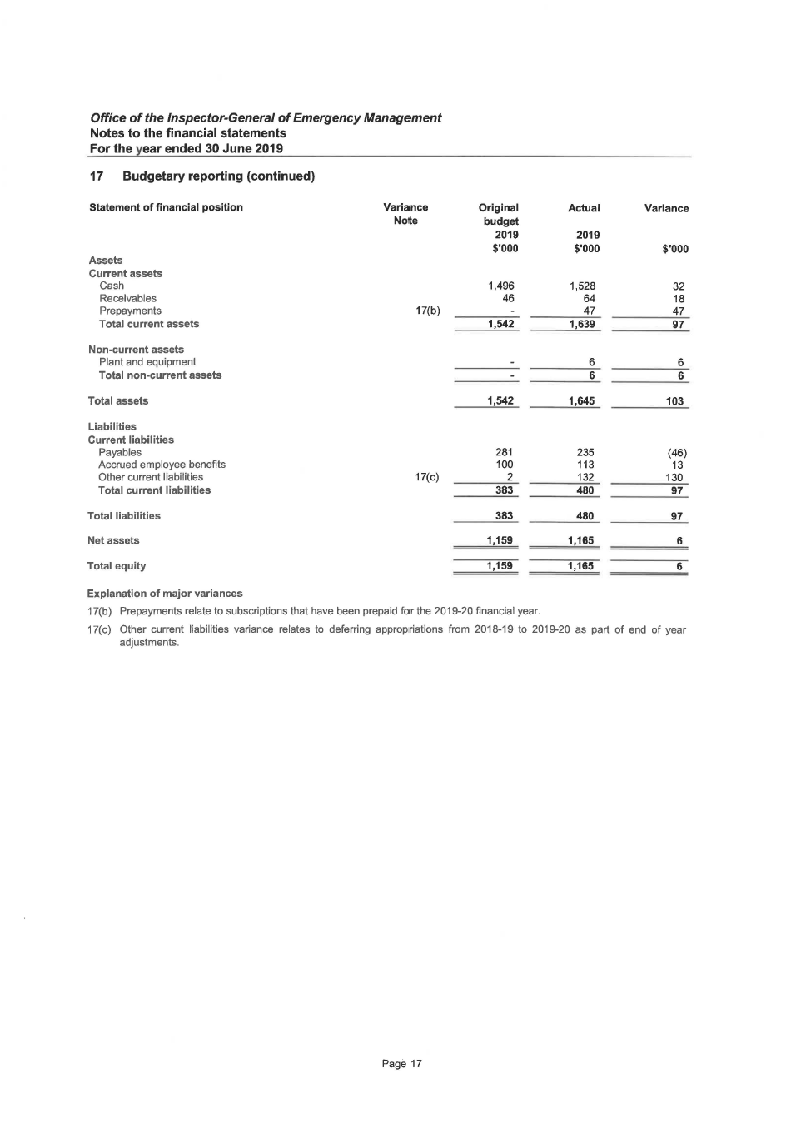

*Office of the Inspector-General of Emergency Management*

Notes to the financial statements

For the year ended 30 June 2019

17 Budgetary reporting (continued)

Statement of financial position

Assets

Current assets

Cash

Receivables

Prepayments

Total current assets

Non-current assets

Plant and equipment

Total non-current assets

Total assets

Liabilities

Current liabilities

Payables

Accrued employee benefits

Other current liabilities

Total current liabilities

Total liabilities

Net assets

Total equity

Explanation of major variances

Variance

Note

17(b)

17(c)

Original

budget2019

$'000

1,496

46

1,542

1,542281

100

2

383

383

1,159

1,159

17(b) Prepayments relate to subscriptions that have been prepaid for the 2019-20 financial year.

Actual Variance

2019

$'000 $'000

1,528 32

64 18

47 47

1,639 97

6 6

6 6

1,645 103

235 (46)

113 13

132 130

480 97

480 97

1,165 6

1,165 6

17( c) Other current liabilities variance relates to deferring appropriations from 2018-19 to 2019-20 as part of end of year

adjustments.

Page

## Certification of financial statements

*Office of the Inspector-General of Emergency Management*

Notes to the financial statements

For the year ended 30 June 2019

17 Budgetary reporting (continued)

Statement of cash flows

Cash flows from operating activities

*Inflows:*

Services appropriation receipts

User charges and fees

Grants and other contributions

GST input tax credits from ATO

GST collected from customers

*Outflows:*

Employee expenses

Supplies and services

Grants and subsidies

GST paid to suppliers

GST remitted to ATO

Other

Net cash provided by/(used in) operating activities

Net increase/( decrease) in cash

Cash at beginning of financial year

Cash at end of financial year

Explanation of major variances

Nil material variances.

Variance

Note

Page 18

Original

budget

2019

$'000

4,209

4

(2,939)

(1,248)

(26)

1,496

1,496

Actual Variance

2019

$'000 $'000

4,341 132

13 9

119 119

1 1

(2,969) (30)

(1,226) 22

(10) (1 0)

(132) (132)

(1) (1)

(145) {119)

(9) (9)

(9) (9)

1,537 41

1,528 32

***Office of the Inspector-General of Emergency Management***

**Management Certificate for the year ended 30 June 2019**

**Management Certificate**

These general purpose financial statements have been prepared pursuant to section 62(1) of the *Financial Accountability Act*

*2009* (the Act), section 42 of the *Financial and Performance Management Standard 2009* and other prescribed requirements. In

accordance with section 62( 1 )(b) of the Act we certify that in our opinion:

(a) the prescribed requirements for establishing and keeping the accounts have been complied with in all material respects;

(b) the financial statements have been drawn up to present a true and fair view, in accordance with prescribed accounting

standards, of the transactions of the Office of the Inspector-General of Emergency Management for the year ending 30

June 2019 and of the financial position of the office at the end of that year; and

(c) the Inspector-General Emergency Management, as the Accountable Officer, acknowledges responsibility under s.B and

s.15 of the *Financial and Performance Management Standard 2009* for the establishment and maintenance, in all

material respects, of an appropriate and effective system of internal controls and risk management processes with

respect to financial reporting throughout the reporting period.

Alistair Dawson APM

A/Accountable Officer

A/1 nspector-General Emergency Management

Date *2 q I ( I* //

Page 19

Wayne Brummer

B.Bus (Acctg), Grad Cert Prof Acctg

MIPA, GAICD

Chief Finance Officer

## Independent Auditor’s Report

**INDEPENDENT AUDITOR’S REPORT**

To the Accountable Officer of the Office of the Inspector-General of Emergency Management

**Report on the audit of the financial report**

**Opinion**

I have audited the accompanying financial report of the Office of the Inspector-General of Emergency Management.

In my opinion, the financial report:

1. gives a true and fair view of the department's financial position as at 30 June 2019, and its financial performance and cash flows for the year then ended
2. complies with the *Financial Accountability Act 2009*, the Financial and Performance Management Standard 2009 and Australian Accounting Standards.

The financial report comprises the statement of financial position as at 30 June 2019, the statement of comprehensive income, statement of changes in equity, statement of cash flows for the year then ended, notes to the financial statements including summaries of significant accounting policies and other explanatory information, and the management certificate.

**Basis for opinion**

I conducted my audit in accordance with the *Auditor-General of Queensland Auditing Standards*, which incorporate the Australian Auditing Standards. My responsibilities under those standards are further described in the *Auditor’s Responsibilities for the Audit of the Financial Report* section of my report.

I am independent of the department in accordance with the ethical requirements of the Accounting Professional and Ethical Standards Board’s APES 110 *Code of Ethics for Professional Accountants* (the Code) that are relevant to my audit of the financial report in Australia. I have also fulfilled my other ethical responsibilities in accordance with the Code and the *Auditor-General of Queensland Auditing Standards*.

I believe that the audit evidence I have obtained is sufficient and appropriate to provide a basis for my opinion.

**Key audit matters**

I have determined that there are no key audit matters to communicate in my report.

**Responsibilities of the department for the financial report**

The Accountable Officer is responsible for the preparation of the financial report that gives a true and fair view in accordance with the *Financial Accountability Act 2009*, the Financial and Performance Management Standard 2009 and Australian Accounting Standards, and for such internal control as the Accountable Officer determines is necessary to enable the preparation of the financial report that is free from material misstatement, whether due to fraud or error.

The Accountable Officer is also responsible for assessing the department's ability to continue as a going concern, disclosing, as applicable, matters relating to going concern and using the going concern basis of accounting unless it is intended to abolish the department or to otherwise cease operations

**Auditor’s responsibilities for the audit of the financial report**

My objectives are to obtain reasonable assurance about whether the financial report as a whole is free from material misstatement, whether due to fraud or error, and to issue an auditor’s report that includes my opinion. Reasonable assurance is a high level of assurance, but is not a guarantee that an audit conducted in accordance with the Australian Auditing Standards will always detect a material misstatement when it exists. Misstatements can arise from fraud or error and are considered material if, individually or in aggregate, they could reasonably be expected to influence the economic decisions of users taken on the basis of this financial report.

As part of an audit in accordance with the Australian Auditing Standards, I exercise professional judgement and maintain professional scepticism throughout the audit. I also:

* Identify and assess the risks of material misstatement of the financial report, whether due to fraud or error, design and perform audit procedures responsive to those risks, and obtain audit evidence that is sufficient and appropriate to provide a basis for my opinion. The risk of not detecting a material misstatement resulting from fraud is higher than for one resulting from error, as fraud may involve collusion, forgery, intentional omissions, misrepresentations, or the override of internal control.
* Obtain an understanding of internal control relevant to the audit in order to design audit procedures that are appropriate in the circumstances, but not for expressing an opinion on the effectiveness of the department's internal control.
* Evaluate the appropriateness of accounting policies used and the reasonableness of accounting estimates and related disclosures made by the department.
* Conclude on the appropriateness of the department's use of the going concern basis of accounting and, based on the audit evidence obtained, whether a material uncertainty exists related to events or conditions that may cast significant doubt on the department's ability to continue as a going concern. If I conclude that a material uncertainty exists, I am required to draw attention in my auditor’s report to the related disclosures in the financial report or, if such disclosures are inadequate, to modify my opinion. I base my conclusions on the audit evidence obtained up to the date of my auditor’s report. However, future events or conditions may cause the department to cease to continue as a going concern.
* Evaluate the overall presentation, structure and content of the financial report, including the disclosures, and whether the financial report represents the underlying transactions and events in a manner that achieves fair presentation.

I communicate with the Accountable Officer regarding, among other matters, the planned scope and timing of the audit and significant audit findings, including any significant deficiencies in internal control that I identify during my audit.

In accordance with s.40 of the *Auditor-General Act 2009*, for the year ended 30 June 2019:

1. I received all the information and explanations I required.

In my opinion, the prescribed requirements in relation to the establishment and keeping of accounts were complied with in all material respects.

 30 August 2019  
John Welsh  
as delegate of the Auditor-General Queensland Audit Office  
 Brisbane

Queensland Audit Office  
 Brisbane

# Appendices

## Glossary

|  |  |
| --- | --- |
| **Acronym** | **Definition** |
| Assurance and Excellence Development Program (AEDP) | An internal tool that guides how the Office conducts its core business of review and assurance activities |
| AFSM | Australian Fire Service Medal |
| AIDR | Australian Institute for Disaster Resilience |
| APM | Australian Police Medal |
| ARR | Annual report requirements for Queensland Government agencies |
| CaPE | Conduct and Performance Excellence |
| CCC | Crime and Corruption Commission |
| DFV | Domestic and Family Violence |
| Disaster Management Officers’ Network | A statewide peer-driven network of disaster management officers and local disaster coordinators from councils across Queensland |
| Disaster Management Research Framework (the Research Framework) | Collaboratively develops and promotes disaster management research for the Queensland context |
| Emergency Management Assurance Framework (the Framework) | Provides the context for continuous improvement in the disaster management sector, and the structure and mechanism for reviewing and assessing the effectiveness of Queensland’s disaster management arrangements |
| Executive Management Committee (EMC) | The Office’s senior leadership group |
| FAA | *Financial Accountability Act 2009* |
| FTE | Full-Time Equivalent |
| FPMS | *Financial and Performance Management Standard 2009* (until 31 August 2019)  *Financial and Performance Management Standard 2019* (from 1 September 2019) |
| IGEM | Inspector-General Emergency Management |
| IGEMx | IGEM Business Excellence Program |
| Inspector-General Emergency Management Advisory Panel (IGEM Advisory Panel) | Provides advice to the Inspector-General Emergency Management and guides strategic disaster management policy development and associated projects and initiatives |
| Lessons management program | Enables learnings from events, exercises and good practice to be identified and embedded through action and change |
| MBA | Master of Business Administration |
| MBE | Member of the Order of the British Empire |
| PID | Public Interest Disclosure |
| PSP ARC | Public Safety Portfolio Audit and Risk Committee |
| PSA ARCC | Public Safety Agencies Audit, Risk and Compliance Committee |
| Public Safety Business Agency and Inspector-General Emergency Management Audit, Risk and Compliance Committee (PSBA and IGEM ARCC) | Provides oversight of audit, risk and management compliance activities related to the Public Safety Business Agency and the Office |
| PSBA | Public Safety Business Agency |
| QAO | Queensland Audit Office |
| QFES | Queensland Fire and Emergency Services |
| QO | Queensland Ombudsman |
| QPS | Queensland Police Service |
| Queensland Disaster Management Committee (QDMC) | The state group, established under section 17 of the *Disaster Management Act 2003*, provides reports and makes recommendations, where appropriate, about matters relating to disaster management and disaster operations |
| Queensland Disaster Management Lexicon (the Lexicon) | A resource document that supports the use of a shared language in Queensland’s disaster management sector. Refer to the Queensland Disaster Management Lexicon for definitions applicable to Queensland’s disaster management sector at [www.igem.qld.gov.au](http://www.igem.qld.gov.au/) |
| Queensland State Disaster Management Plan | Outlines the principles of disaster management in Queensland, describes the roles and responsibilities of disaster management stakeholders to support disaster management as legislated in the *Disaster Management Act 2003* and outlines the arrangements for prevention, preparedness, response, recovery and resilience |
| Research Advisory Panel | Supports the Disaster Management Research Framework and includes representatives from state government agencies, local government and Queensland universities |
| SDS | Service Delivery Statement |
| Standard for Disaster Management in Queensland (the Standard) | Establishes the performance requirements for all entities involved in disaster management |
| State Disaster Coordination Group (SDCG) | Supports the State Disaster Coordinator including providing advice about available resources and options for disaster response operations |
| Working for Queensland survey | An annual survey that measures Queensland public sector employee perceptions of their work, manager, team and organisation |

## Compliance checklist

|  |  |  |  |
| --- | --- | --- | --- |
| Summary of requirement | | Basis for requirement | Annual report reference |
| Letter of compliance | **A letter of compliance from the accountable officer or statutory body to the relevant Minister/s** | ARRs *–* section 7 | 3 |
| Accessibility | **Table of contents**  **Glossary** | ARRs – section 9.1 | 4  58-59 |
| **Public availability** | ARRs – section 9.2 | 2 |
| **Interpreter service statement** | *Queensland Government Language Services Policy*  ARRs – section 9.3 | 2 |
| **Copyright notice** | *Copyright Act 1968*  ARRs – section 9.4 | 2 |
| **Information Licensing** | *QGEA – Information Licensing*  ARRs – section 9.5 | 2 |
| General information | **Introductory Information** | ARRs – section 10.1 | 5 |
| **Machinery of Government changes** | ARRs – section 10.2, 31 and 32 | Not applicable |
| **Agency role and main functions** | ARRs – section 10.2 | 6 |
| **Operating environment** | ARRs – section 10.3 | 7-8 |
| Non-financial performance | **Government’s objectives for the community** | ARRs – section 11.1 | 9 |
| **Other whole-of-government plans / specific initiatives** | ARRs – section 11.2 | 10 |
| **Agency objectives and performance indicators** | ARRs – section 11.3 | 11-22 |
| **Agency service areas and service standards** | ARRs – section 11.4 | 21-22 |
| Financial performance | **Summary of financial performance** | ARRs – section 12.1 | 23-25 |
| Governance – management and structure | **Organisational structure** | ARRs – section 13.1 | 26 |
| **Executive management** | ARRs – section 13.2 | 27 |
| **Government bodies (statutory bodies  and other entities)** | ARRs – section 13.3 | Not applicable |
| ***Public Sector Ethics Act 1994*** | *Public Sector Ethics Act 1994*  ARRs – section 13.4 | 29 |
| **Queensland public service values** | ARRs – section 13.5 | 29 |
| Governance – risk management and accountability | **Risk management** | ARRs – section 14.1 | 30 |
| **Audit committee** | ARRs – section 14.2 | 31-32 |
| **Internal audit** | ARRs – section 14.3 | 33 |
| **External scrutiny** | ARRs – section 14.4 | 34-35 |
| **Information systems and recordkeeping** | ARRs – section 14.5 | 36 |
| Governance – human resources | **Strategic workforce planning and performance** | ARRs – section 15.1 | 16-19 |
| **Early retirement, redundancy and retrenchment** | Directive No.04/18 *Early Retirement, Redundancy and Retrenchment*  ARRs – section 15.2 | 17 |
| Open Data | **Statement advising publication of information** | ARRs – section 16 | 2 |
| **Consultancies** | ARRs – section 33.1 | https://data.qld.gov.au |
| **Overseas travel** | ARRs – section 33.2 | https://data.qld.gov.au |
| **Queensland Language Services Policy** | ARRs – section 33.3 | https://data.qld.gov.au |
| Financial statements | **Certification of financial statements** | FAA – section 62  FPMS – sections 42, 43 and 50  ARRs – section 17.1 | 55 |
| Independent Auditor’s Report | FAA – section 62  FPMS – section 50  ARRs – section 17.2 | 56-57 |

FAA *Financial Accountability Act 2009*

FPMS *Financial and Performance Management Standard 2019*

ARRs *Annual report requirements for Queensland Government agencies*

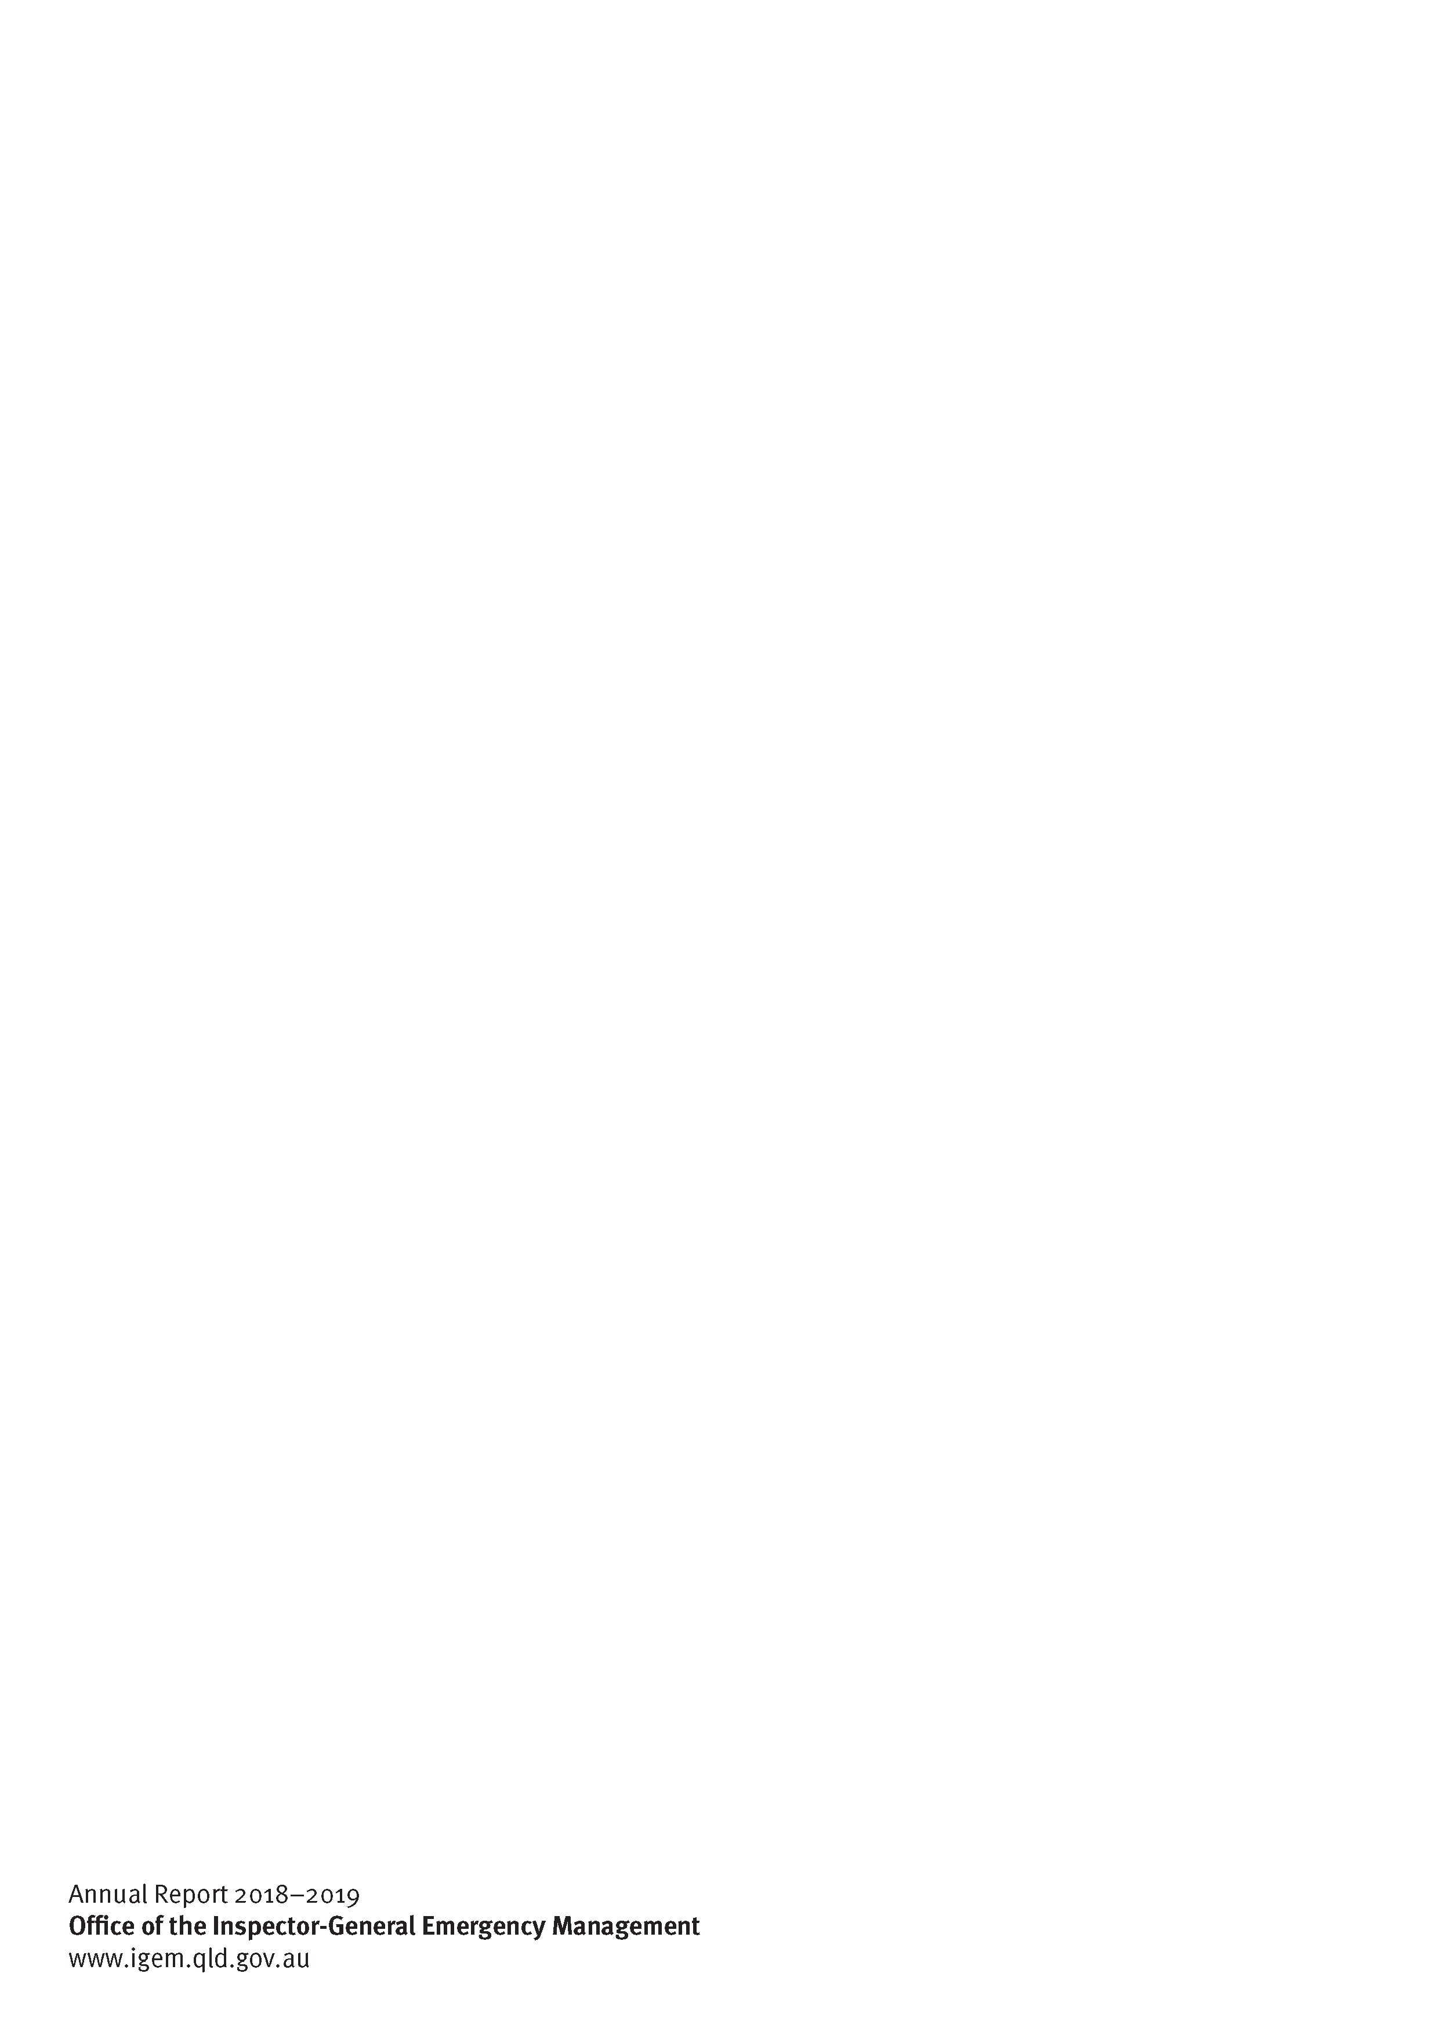**Insert back cover**

Annual Report 2018–2019

**Office of the Inspector-General Emergency Management**

www.igem.qld.gov.au